**Rerun – JS (Focus on What you don’t know or lacking)**

**Tips**

* parseInt(arg) <- to get only integer number

**String**

**String Methods:** Searching, Replacing and Changing

* Methods without arg
  + Thing.method() <- To using string method
  + String.toUpperCase() <- Make all string to Upper case
  + String.toLowerCase() <- Make all string to Lower case
  + String.trim() <- to trim left and right space -> maybe trimEnd or trimStart to specify its side
  + String.trim().toUpperCase() <- We can chain these methods together
* Methods with arg
  + String.methods(arg) <- pass argument into methods (No all methods need arg)
  + String.indexOf(‘Specify string’) <- ‘hello’.indexOf(‘lo’) it will show 3. If it doesn’t have in string it will show -1
  + String.slice(beginIndex, [,endIndex]) <- arg can be one or two up to deciding. “hello”.slice(2) = ‘lo’ ,“hello”.slice(1,3) = ‘ell’ and “hello”.slice(-1) = ‘o’
  + String.replace(exists value, replace value) <- ‘hello gus’.replace(‘ello’,’I’) = ‘hI Gus’
* Template Literal
  + `string ${Accumulation or Methods or Actions or variables that contains something to show} string`
* Null | undefined
  + Null : Intentional absense of any value. Must be assigned
    - Let values = null -> values = 2 , null has to be assigned
  + Undefined : Variables that do not have tan assigned value are undefined
    - It’s about , I don’t know what you are saying or the variable is blank = undefined that’s it!
* Math Methods
  + Math.PI
  + Math.round <- Math.round(1.99) = 2 , from 1.99 to 2
  + Math.abs <- Math.abs(-1) , |-1| = 1
  + Math.pow <- Math.pow(2,2) = 4 || 2 powers 2 = 4
  + Math.floor <- remove decimal like from Math.floor(5.99) = 5
  + Math.ceil <- Math.ceil(33.01) = 34, only round up
  + Math.random() = random number from 0.0 to 1.0, you can do Math.floor(Math.random()*10) + 1 so it will random from 1 to 10, This is fair then Math.round(Math.random()*10) because of its bias. See its prop below
    - 0 | 0.05
    - 1–9 | 0.10 each
    - 10 | 0.05
  + const roll = `You rolled a ${die1} and a ${die2}. They sum to ${die1 + die2}`

**Decision Making**

* Alert & Prompt
  + Console.warn(arg) -< console.warn(“Don’t”) = Don’t
  + Console.error(arg) <- console.error(“Don’t”) = Don’t
  + Alert(arg)
  + Prompt(arg) <- Input prompt. It will pop input to screen <- keep as STRING

**Array**

* Index
  + let array = [] <- to create an array empty
  + Array[-1] != last element <- it doesn’t like string’s index
  + Array[1][0] <- [index array][index letter or something else] <- arr = [‘red’,’green’] <- arr[0][1] = ‘e’ (from red)
* Methods
  + Array.length <- counting elements in array
  + Array.push(arg) <- Add element to the end of an array (to last seq.)
  + Array.pop() <- Remove element from the end of an array (from last seq.)
    - It’s more special, cause It doesn’t want any arg to pass to, and it will return its value. The value that’s returned is the last element that it was pop.
  + Array.shift() <- Remove element from the beginning of an array (from the first seq.[0])
    - It’s similary to the array.pop()
    - It’s doesn’t need arg to pass to.
    - It’ll return the value of the beginning array, so maybe you can use variable to get that
  + Array.Unshift(arg) <- add element to the begining of an array (to first seq.[0])
  + Array.concat(array): mearge array
    - Const array3 = array1.concat(array2) // make an new array with concat
  + Array.includes(arg): look for a value
    - Array.includes(value to find can be string or number)
    - answer as boolean
  + Array.reverse(): reverse an array
    - Bottom up
  + Array.indexOf(arg): just like string.indexOf
    - Array.indexOf(value to find can be string or number)
    - answer as index of an array
    - answer = -1 = Doesn’t have that value in that array
  + Array.join(): create a string from an array
  + Array.slice(arg): cpoies a protion on an array
    - Array.slice(index’s array) <- like this it will copy to the new array from that specify index to the end
    - [‘a’,’b’,’c’,’d’].slice(3) = [‘c’,’d’] <- this not related to its original array, it will be new array
    - Array.slice(index start,index end) <- this also works for start and end index
  + Array.splice(): removes/replaces elements
    - Array.splice(index array,Amount to delete, some things to be inserted)

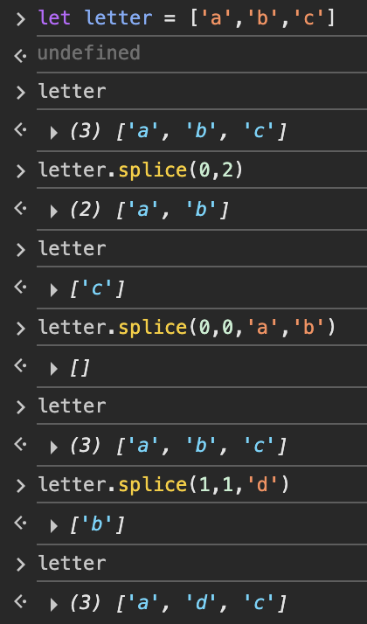

* + - Above is the possible things you can do with splice, like to insert between index, or just delete.
  + Array.sort(): sort an array
    - Its method for work is comparison by convert any elements to string then compare them by using UTF-16 code
    - Colt said it kind of useless and difficult to do
    - It doesn’t need arg to pass in
* Reference Types & Equality Testing

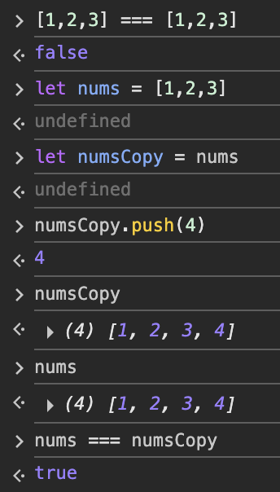

* + From above Example, It’s about the Memory
  + On first line you can see form their comparison it tell us ‘false’ because of the left array we are created, it take memory for it then we are create a new one on right side it takes on another memory, so when we are comparing them, it said ‘false’ from this memory puspose
  + The other lines, I have created variables for nums and numsCopy, if you notice something I have push the new value to numsCopy then I log to see the variable nums value. It has the value as the same as numsCopy, the idea on array it doesn’t know what exactly the values are, but they point to the memory, so when I do numsCopy = nums it has pointed to the same memory, so it shared their memory to each other.
  + From all explanation. Array is using the memory idea or arrow pointing to point on memory. It doesn’t like string.
  + If we want to compare them, We must Do the other thing like ‘.map’ or loop to caomparison its value in array.
* Const & array

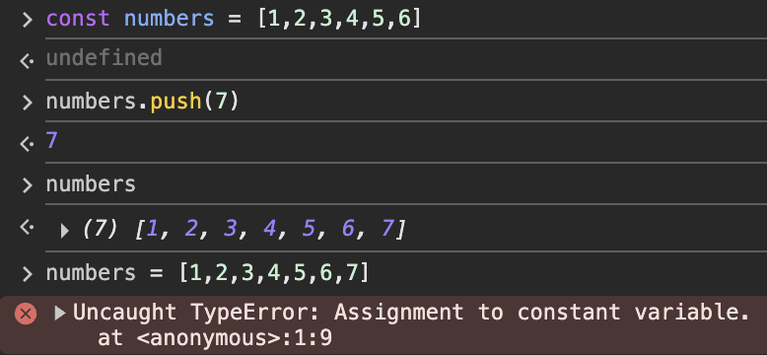

* + Const is unchangable in string but in array it has 2 perspectives that must be considered
  + From above Example, you can see we can alter it, like push or pop also splice or anything because of idea of *arrow pointing* like previous topic array has pointed to the memory, so we could do anything if the memory had the same
  + But We can’t assign array to new value like I have done I have put entirely new array (but has the same element) to numbers array. It caused error.
  + So, for array we can using const or let for it, it up to the purpose for using.
* Multi-Dimensional array (Also known as Nested array)
  + const array = [[‘X’,null,’O’],

[null,’X’,’O’],

[‘O’,’O’,’X’]]

* + Array[0] = [‘X’,null,’O’]
  + Array[0][2] // ‘O’
  + We can alter them directly for dimensional although we using const for array declaration
    - Like this: Array[0][2] = ‘X’

**Object Literals**

**Object:** Stored data like an array but it contains Key and Value pairs

* Objects are collections of **Properties** ,properties are a key-value
* Rather than index, we using custom keys to access value
* Can store any data type(array(object), strings, numbers)
* Create Object
  + Const variableName = {key: ”string”, key2, number,Key3:[array]}
* Accesing Object
  + Object[“key”] <- get value of this object with its key, key
  + Object.key <- This is also work <- this way more popular, I think
  + Tricky way: There is a certain thing to know
    - You can do like:

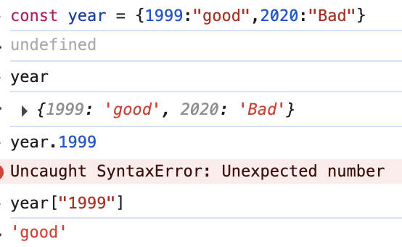

* + - You will see, I have declared the const year with number key, then I used year.1999 <- This didn’t work. I have to converted it to string like year[“1999”] to make it works
    - This does not only be number but it also work with boolean with true or false if you were declaring as key

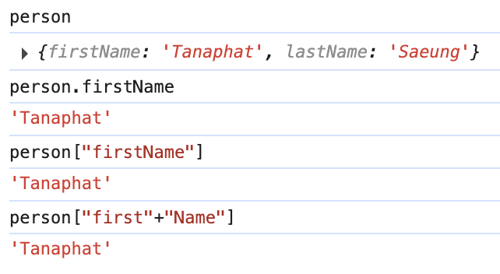

* + - You can do this too with the last line on example, You can integrate the key string to get its value
* Modifying Objects
  + Object.key = value to change
  + Object[“key”] = value to change

**Loops**

**Loops:** Stored data like an array but it contains Key and Value pairs There are multiple types: for loop, while loop, for..of loop, for..in loop

* For loop
  + for (let i = 1; i<= 10; i++ { do something..}
* For loop with an array
  + for (let i = 1; i<= array.length; i++){array[i]}
* While Loop
  + While(num<10){

Do some thing

num++ // <- If doesn’t put this, it may cause the infinite loop

}

* + Break keyword
    - This keyword mostly using for while loop to braek the loop
    - While(true){

Do some thing

If(something){

Break // To exit the loop

}

num++

}

* + - The break keyword can use with all loop not only while loop, but it only works on loop not other to break
* For Of Loop
  + for(let item of array){

do something

}

* + fetch each row || data from array
  + using on object or array, but for object maybe we have to do more than array
  + ***Recommand to work with array rather than object***
* Iterating over object
  + for (let items of

Object.values(ObjectName)) {

console.log(items);

}// red means command, it fixed <- This means to get value from object

**Leveling up function**

Make the fucntion more clearer or more idea for them

* Scope <- it means the declaration about where it’s decleared? There it will appear or access.
* Function Scope:

let a = ‘cat’;

function animal(){

a = ‘dog’

}

animal() // call function here

console.log(a) // ‘dog’

* + The declaration is on outside the function so this is global declaration, we can change the value of a variable

function animal(){

let a = ‘dog’

}

animal() // call function here

console.log(a) // ‘error

* + Now ‘a’ is declaring inside the function, so it is locally declaration, althoug we call function then log, it doesn’t appear and doesn’t know that variable.

let deadlyAnimal = "Blue-Ringed Octopus";

function handleAnimal() {

let deadlyAnimal = "Scorpionfish";

console.log(deadlyAnimal);

}

handleAnimal();

console.log(deadlyAnimal)

* + The results are:
    - Scorpionfish
    - Blue-Ringed Octopus
  + Because it declared twice

const creature = "Common Sea Dragon";

function scubaDive(){

const creature = "Spanish Dancer"; //A type of sea slug

console.log(creature);

}

scubaDive();

* + The result is “Spanish Dancer” because of the declaration is inside the function.
  + Const is unchangable, this is not changing the value but re-declaring
* Block Scope:
  + It means anythings that using curry bracket {}, so in that curly bracket is locally declearation.
    - If, for, etc…
  + The rule is the same as *scope function*
  + But the variable that’s declared by *var* is exceptional
    - var variable = something <- The place that it’s put, not matter at all it still globally variable (That’s why they create const and let to put in scope for choosing the scope and preventing the problem)
* Lexical Scope

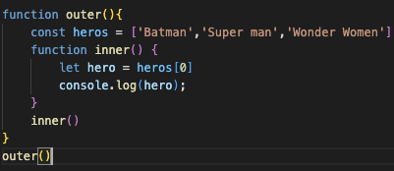



* + It can log to see the value
  + This is lexical scope

**This part will be crucial on call back part**

* Function Expression <- one of the function declaration type

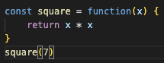

* Higher Order Functions

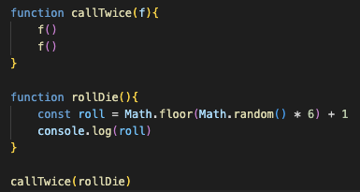

* + Pass function to another function
  + Accept other function as arguments

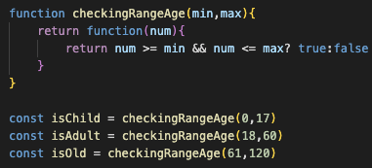

* + Above is the example of higher order functions, about how to *return function*
  + In console

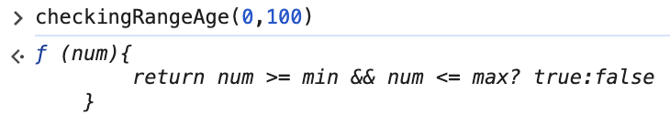

* + - If we invorke this function, we will get a function to return value
    - So how to get its value, we have to do the declaration for receive a value from this function
    - In the example we have declared the *ischild*, *isAdult* and *isOld*, this is not the simple variable but this it’s the function

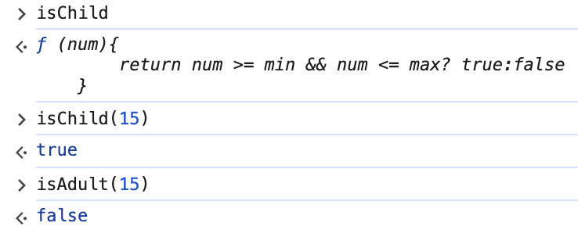

* + - You can see we can pass the arg. To our function for receive value
* To Create Methods
  + This part about We can create our methods, we can create a *function as properties on objectrs*

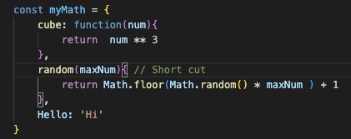

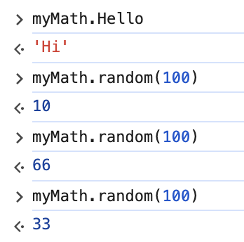

* + We created a function properties on objects, its name is myMath, We can create our Methods( we also can say it’s function)
  + Every Method is a function, but not every function is a Method
  + If you notice on the example of the code part, we can also write the function in *shorthand* for properties on objects
* ‘*This*’ in Methods
  + Use ‘*this*’ to access other properties on the same object
  + Why we prefer *‘This’* Method instead of we can use object.property like below image

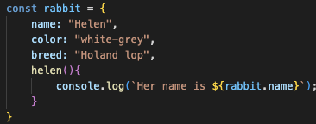

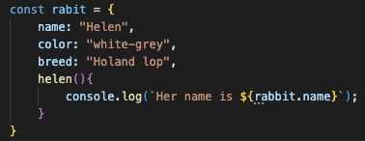

* + it’s about the variable name, If I chenged from rabbit to rabit, I have to change rabbit.name to rabit.name too right. <- So this is why we should use ‘This’ for best practise

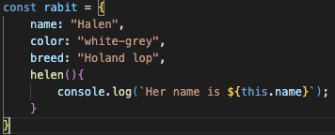

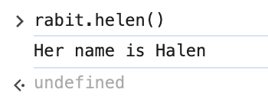

* + Now it a bit of more to understand

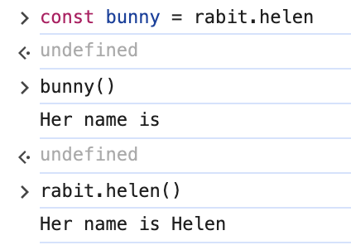

* + Now I assign the function rabit to bunny and I called it. It show me the message but the property this is not shown, because we assign that doesn’t have property ‘name’. <- we have to beware of this situation about ‘this’ methods

**Callbacks & Array Methods**

ForEach Method

* Used to commonly to use befort *for of loop* fasdf
* Loop to get once per item in array
* No need to define index
* To use method:
  + Array.forEach(function(*variable*){dosomething with that *variable*})

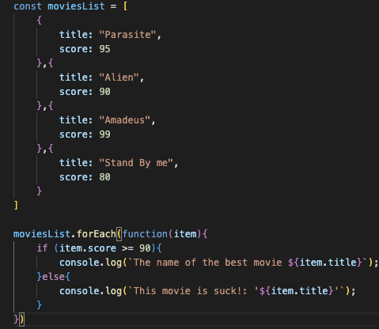

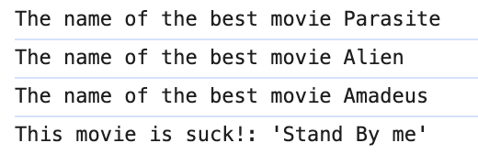

map

* Map accepts a callback function and runs that function once per element in array(like forEach)
* Map *creates a new array* using a result, using the return value of that callback function(like idea of slice method that using on string)
* Reason why we use map:
  + We need to take a portion of the array and transform it into a new array without altering the original one
  + It accepts callback, it runs that callback on every element <- then get that value to new array

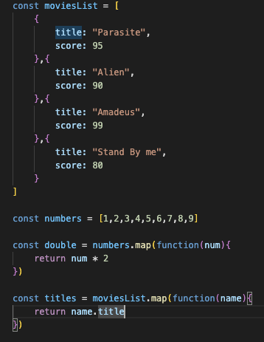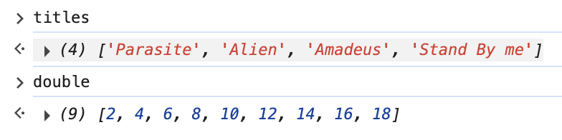

**Implicit Arrow function**

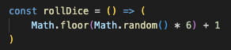

* Implicit return
* It only works at only one statement or expression or one line’s coded

Filter

* We used this method, when want to *filter out* some element in array and *create a new array* one to get the element (same idea as map) 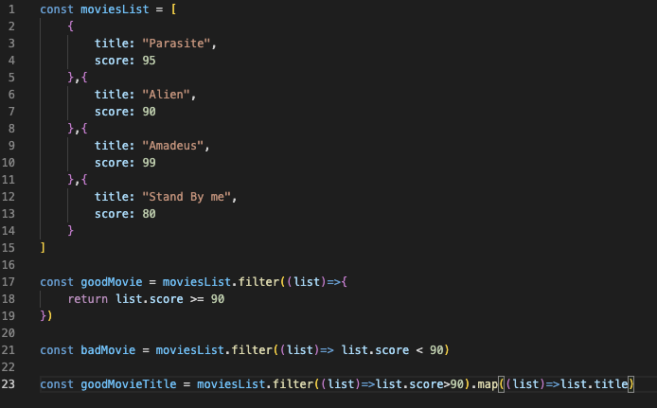

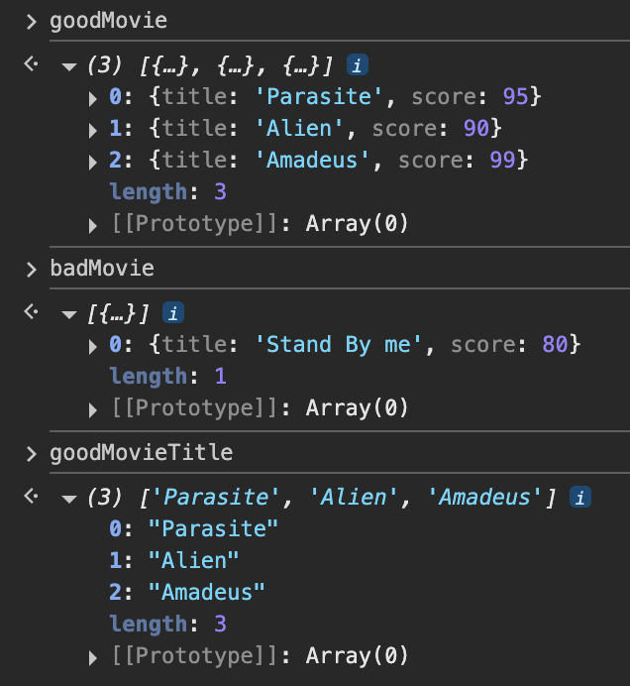

* From good movie, I want to show you about the arrow implicit nothing more that
  + And from those 2 things, we can filter out and create to new array
* From goodMovieTitle we can chain the methods together (map + filter)

Every & some

* It’s the method of test the array
* It’s the method that need to have a callback funtion
* Every
  + if everything in the array is exatly math to its codition, It will return as *True*
  + If it’s have just one element in array that’s not math to its coondition, It will rteturn *False*
* Some
  + like idea of every but opposite
  + just one thing in array mathes, it will return *True,*if not *False*

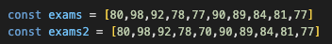

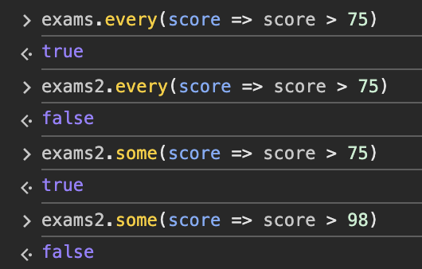

Reduce

* sum every element in array, then get that sum value to variable
* it’s like liquid, we’re combining them all and then we get one drop out
* array.reduce((accumulator,currentValue) => { return something}, initial value for accumulator)
  + accumulator,currentValue <- We don’t need to define them
  + accumulator <- summing
  + currentValue <- represent item individual of the array

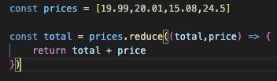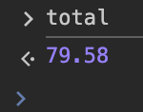

* but reduce can do more than just sum, or multiply, divide, subtraction
* to find min in array

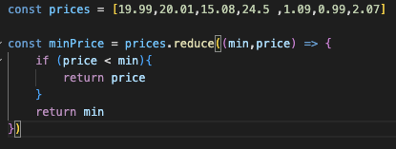

* + You can see, it has been looping all the way to find where is the literraly min value
  + It’s working with callback function(the (min,price)=>{}) all the way to find, so when it find the real one, it return one time <- That’s it
  + This matches to the first idea that reduce will find only one value by accumating every single value though array then return

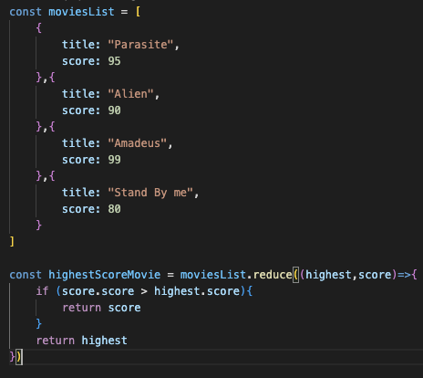 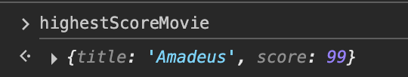

* + With initail value for accumulator

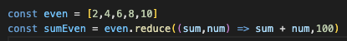 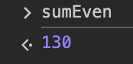

Arrow function with ‘This’ methods

* We can’t use arrow function with ‘This’ method

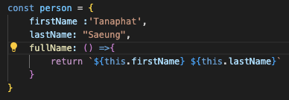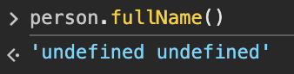

* We *can’t use original function form* with callback funtion like setTimeOut or setInterval

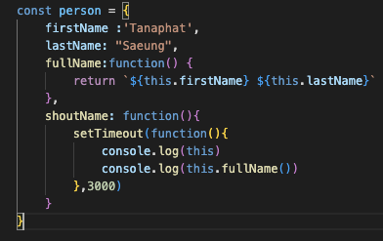

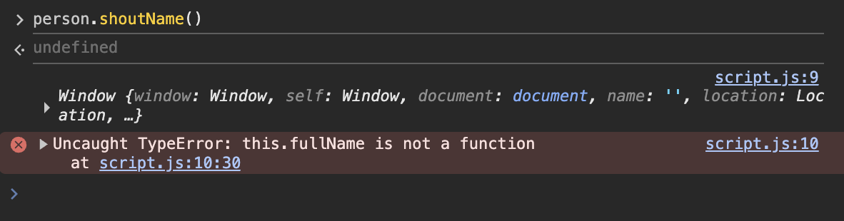

* We Can use Arrow function and must use with ‘This’ method by using it inside callback like setTimeOut() or setInterval()

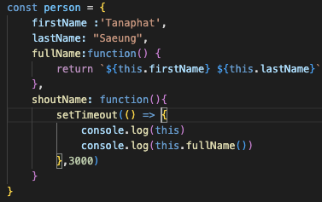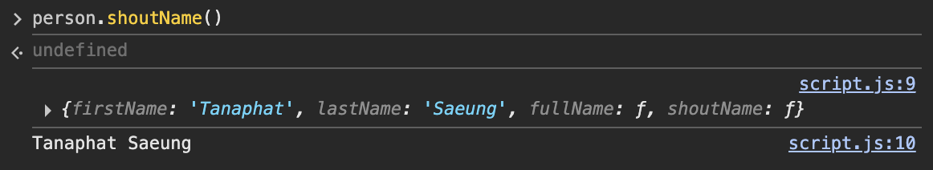

**Newer JS Features**

Default Params

* About the function that has to pass arg, but if user didn’t pass any arg to function, we can set the default for that

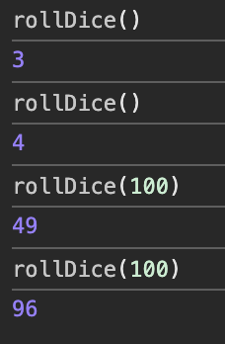

Spread

* This is the feature to *speard* anything
  + From ‘hello’ to h e l l o
  + From [‘Hello’,’Hi’,Yo’] to Hello Hi Yo
* To use spread just use triple dots
* ‘…’ with any variables
* Array:

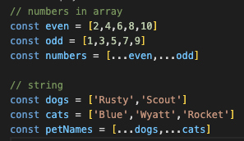

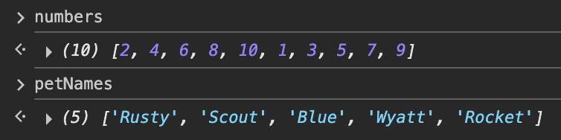

* Object:

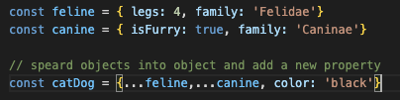 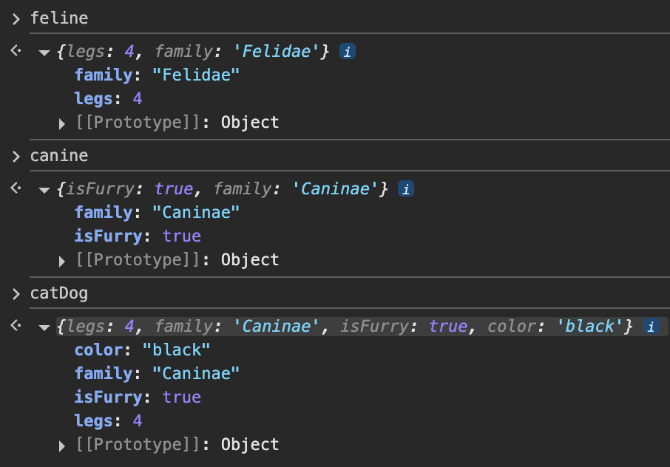

* + From the example, you can see we can create a new object with all new property and add a new one too.
  + If you noticed you will see the ‘family’ property that has the same from 2 objects, the spread will decide the right side as a new one and pull its value to a new array

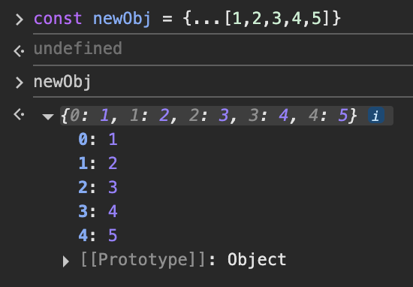

* + Create a new object with new key from array value

Rest

* Look alike ‘Spread’ but entriely different
* *Spead* use to Expanind an array, objects or iterable individual elements
* *Rest* use to collecting(gathering) multiple values into a single array or object

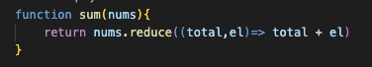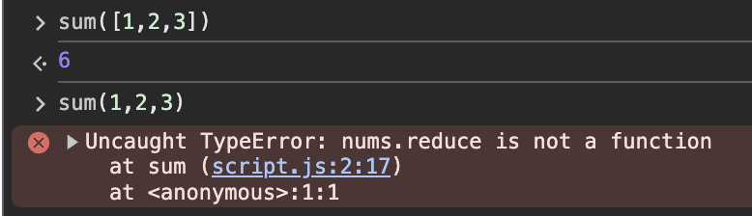

* From this we create a sum function by using reduce to sum up, we have to pass an array number to this function. We can’t pass the standalone value number to it

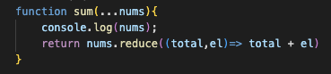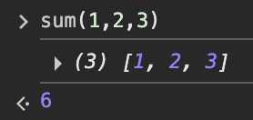

* So, we use *Rest* to create a new for us to using reduce for summing
* The operator of the *Rest* is ‘…’ like spread
* The purpose of using ‘Rest’ feature
  + Normal function vs Arrow function
    - Normal function has built-in of ‘*arguments’* like
    - Function normalFunc(a,b){

return *arguments*

}

normalFunc(1,2,3)

// [1,2,3] <- like *REST*

* + - But arrow function doesn’t have ‘*arguments’* to collect or make an array, so we use ‘Rest. Instead

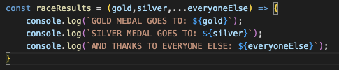 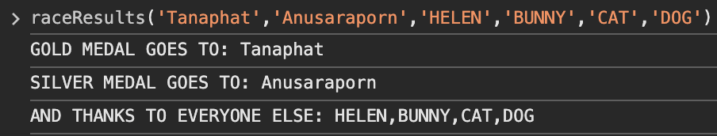

* This was called out the first two specifically then *Rest* come to make ‘everyoneElse’ to be an array <- arguments built in can’t do this

Destucturing arrays

* The way to extraction, unpacking, or singling out value from arrays or objects
* This will put that value to distinct variable

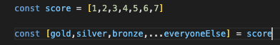

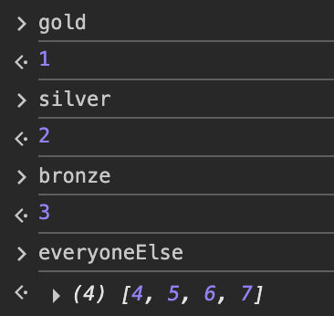

* The Destucturing is ‘const/let [variable] = array]
* The variable has to match to the index’s array
* We can use ‘REST’ to collecting them together

Destucturing Objects

* More commonly use rather than arrays
* Using more on WEB API, like to receive something on body
* To use:
  + {variable’s name in object} = object

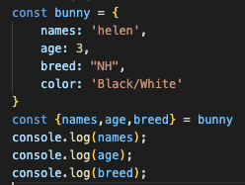 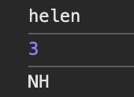

* + We also can rename it by using colon(:)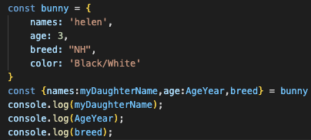

Parm Destructuring

* We can destructuring the parameter that pass to function

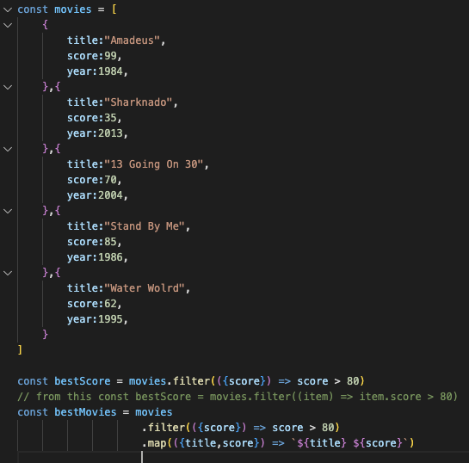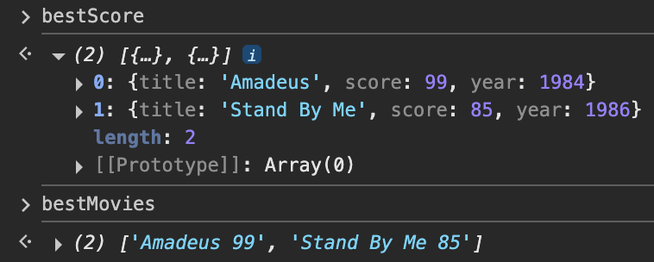

* Make it more shorter

**DOM**

**Document Object Model**

**DOM:** it’s JS object and to combine HTML, CSS and JS together

The Document Object

* It’s ‘root of the tree’ in computer science terms <- From this because of, HTML has its own tree that contains header, body in body has div, ul, li from all these the ‘Document’ is on top of these or ‘the root’

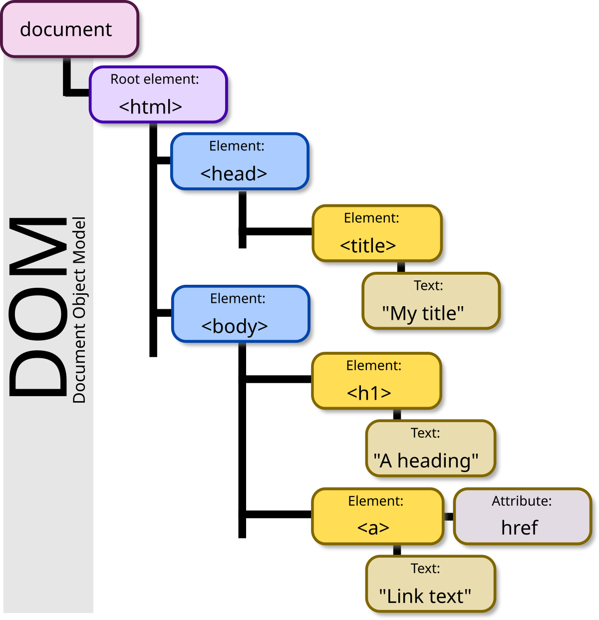

* We can use *‘console.dir(document)’* to see all object in that page
  + Like the value of innerText, innerHTML
* We can use *‘document.all[specific index].method = something’* to alter or changing temporary value without touching html directly
  + If we quit or refresh it will disappear
  + Document.all[10].innerText = ‘Hi’ <- this will change the TEXT that at index 10 from something to ‘Hi’
  + Now we want to change something on wikipedia.com
  + From that I want to change ‘หน้าหลัก’ to ‘GUSTY’



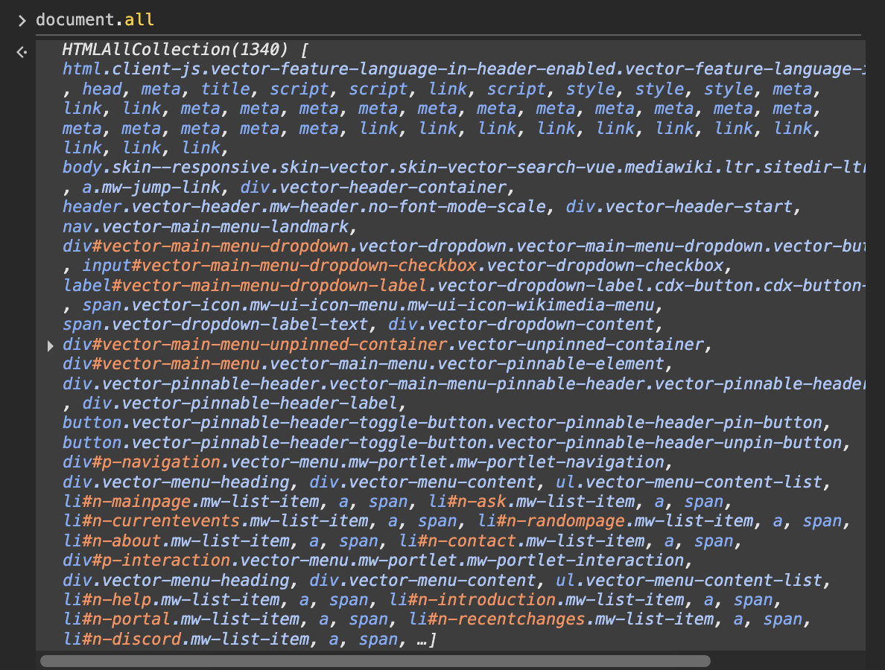

* + First I have to find where is it address(index)

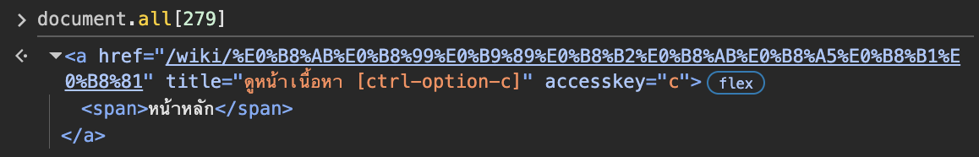

* + When I found it, now I have to find where it is acctually at, like innerHTMl or InnerText (all thing to show is in innerText, the innerHTML is keep tag, if we want to change its tag we can use this)

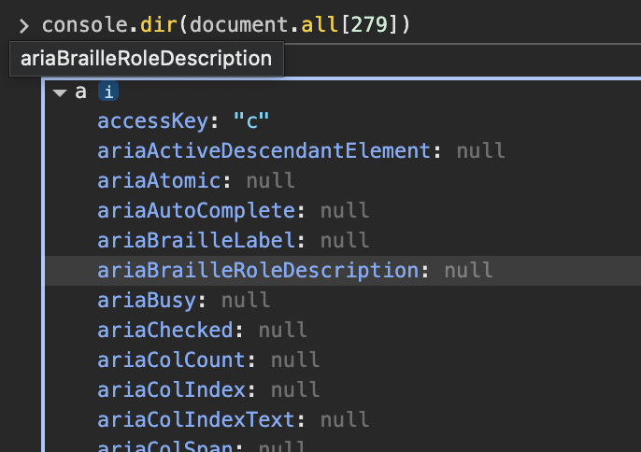

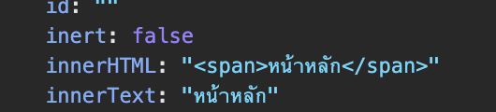

* + So now I can change

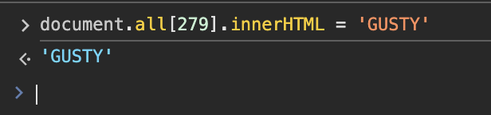

Selecting DOM elements

* getElementById(‘ID’)

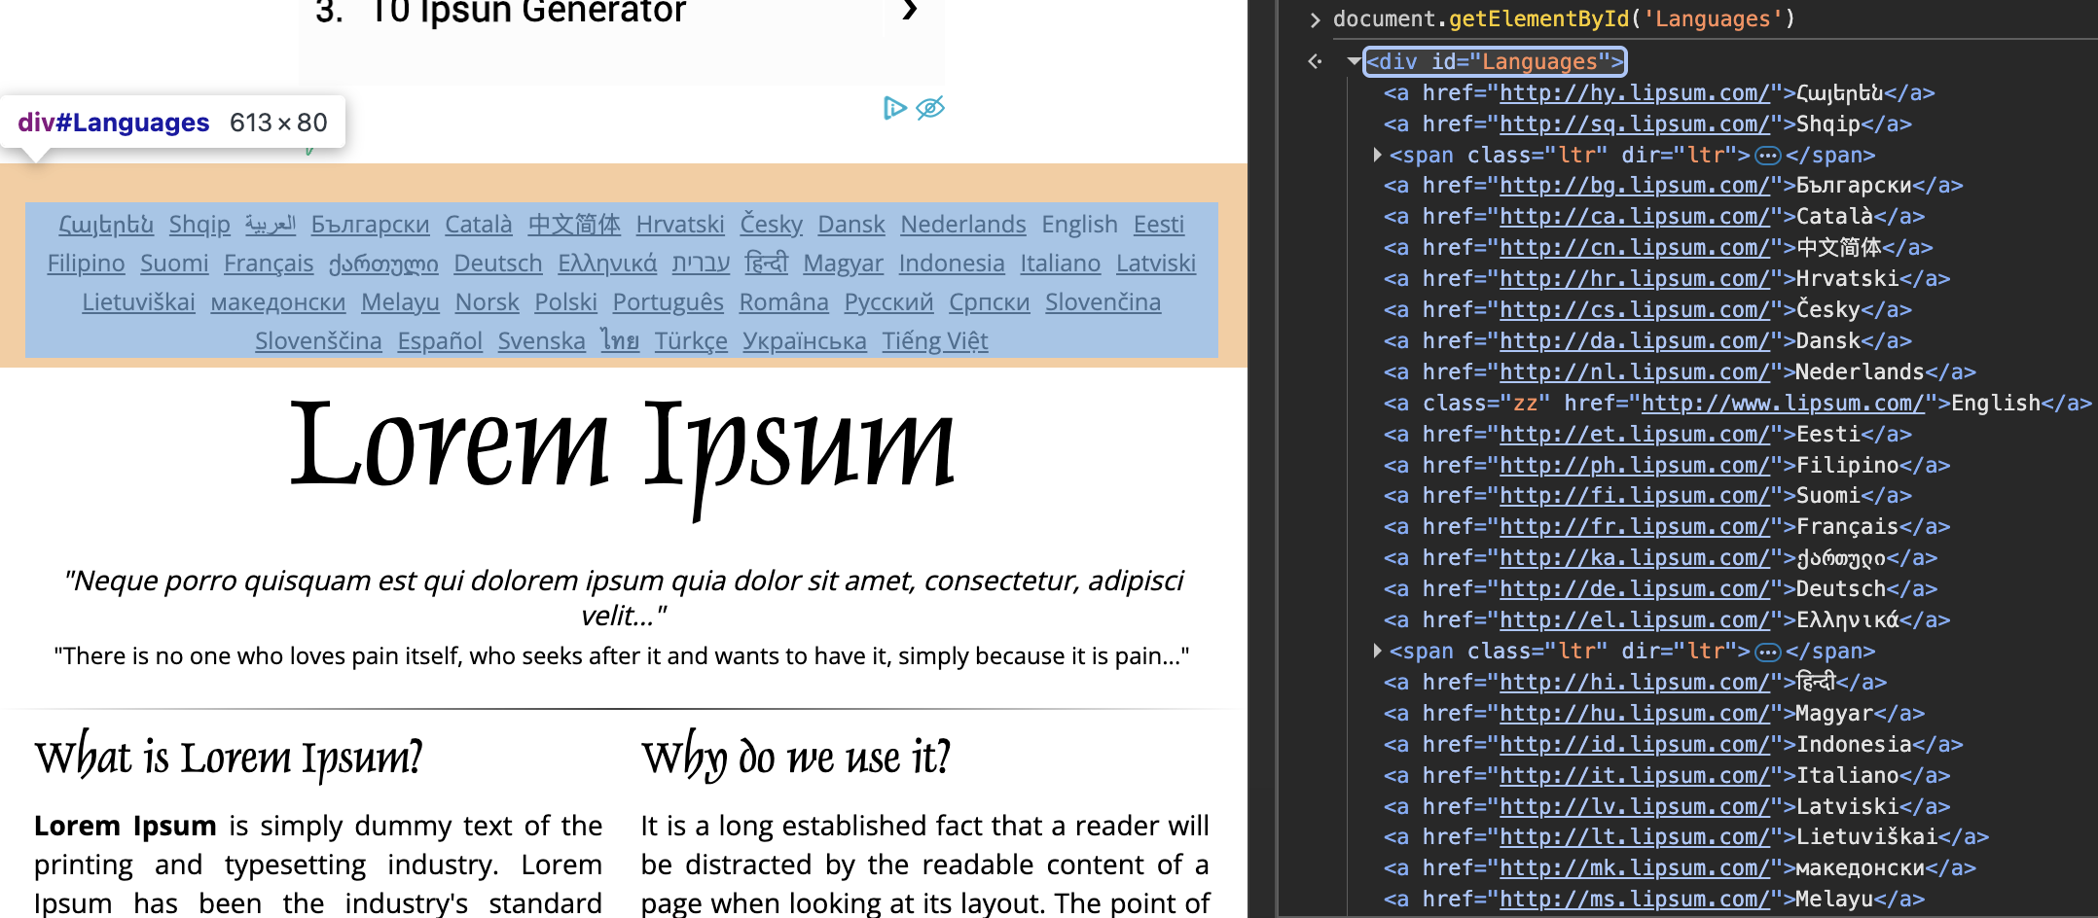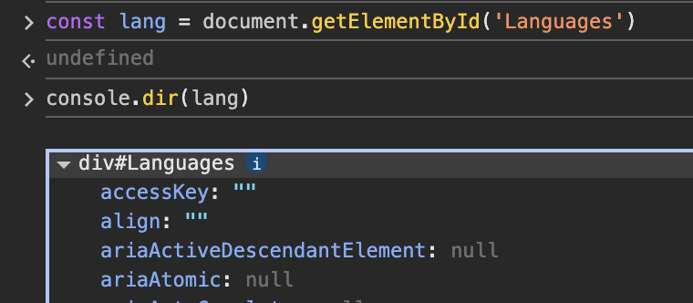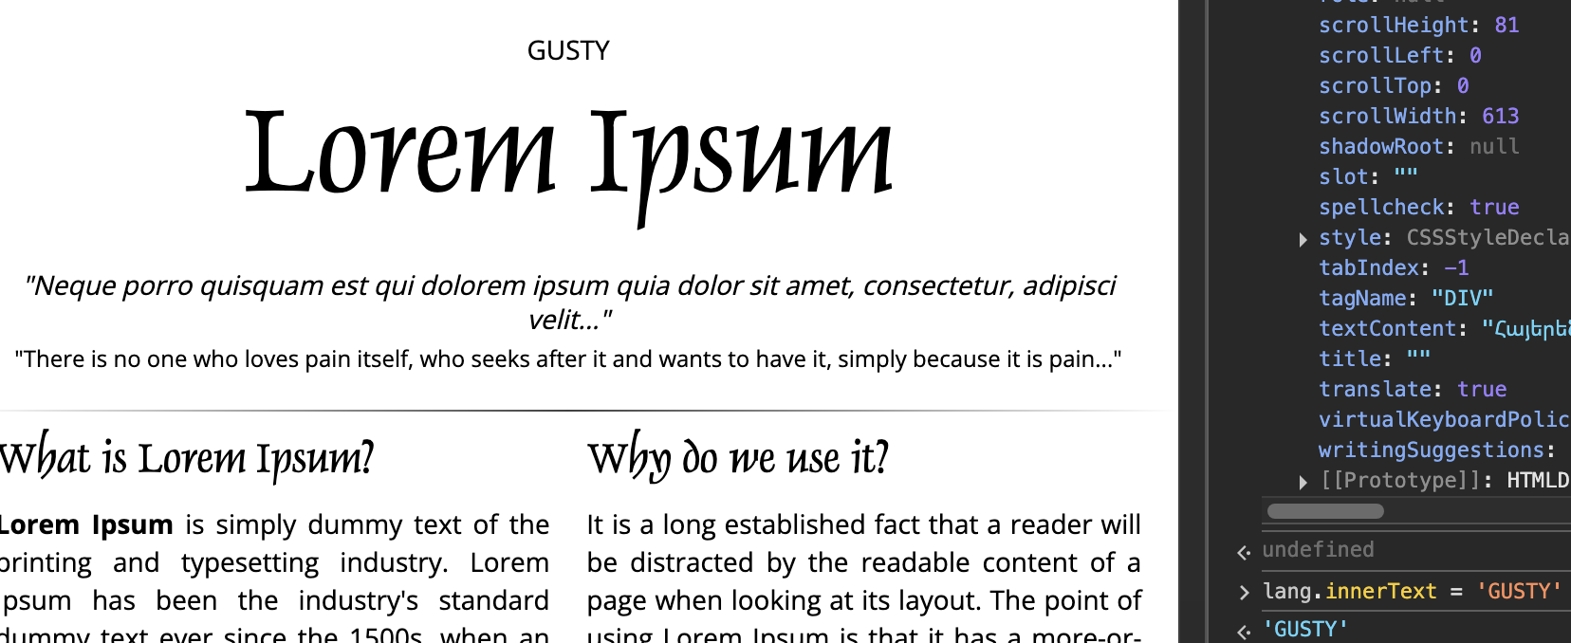

* getElementByTagName(‘tag’)
  + from web: https://shorturl.at/wrbol

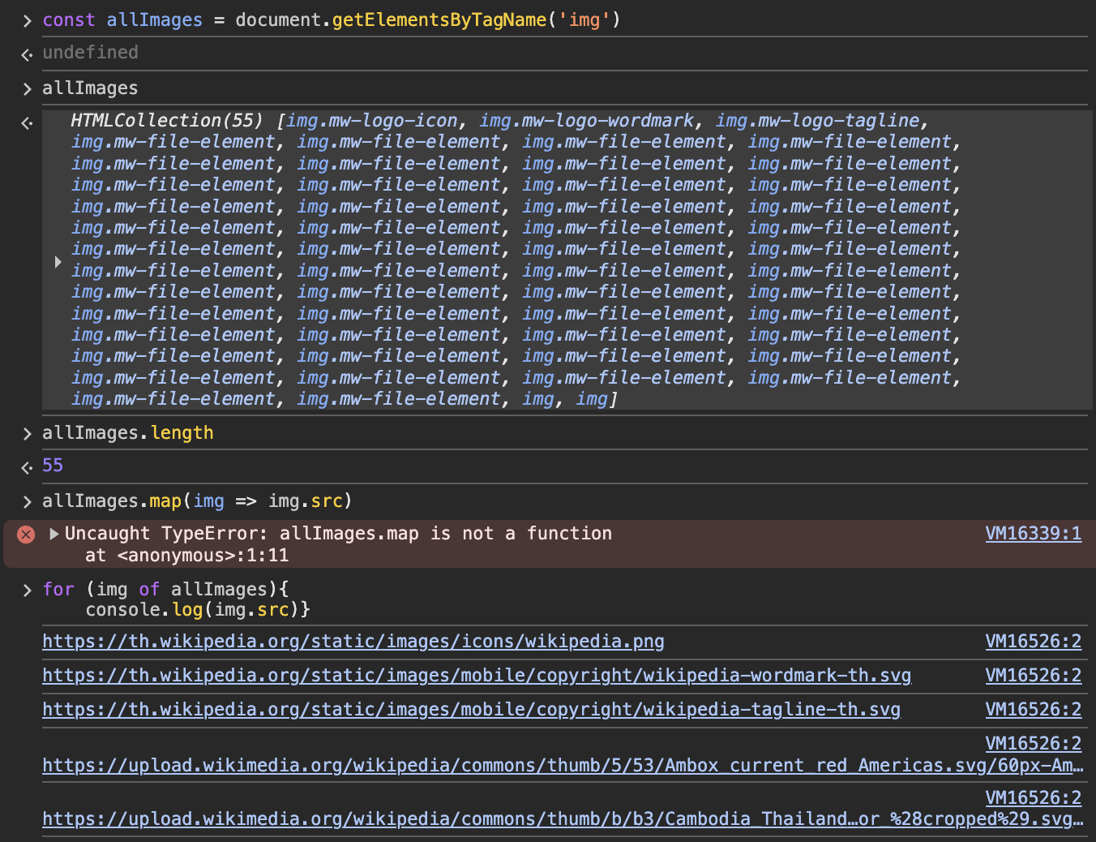

* + from above I try to get all image link from wiki web by using array methods because its data look alike array but it’s not
    - That’s data we called *HTMLCollection*, it has length, and we can access it by index but it’s not real array, so we can’t use array method
* getElementByClassName()
  + to access class name

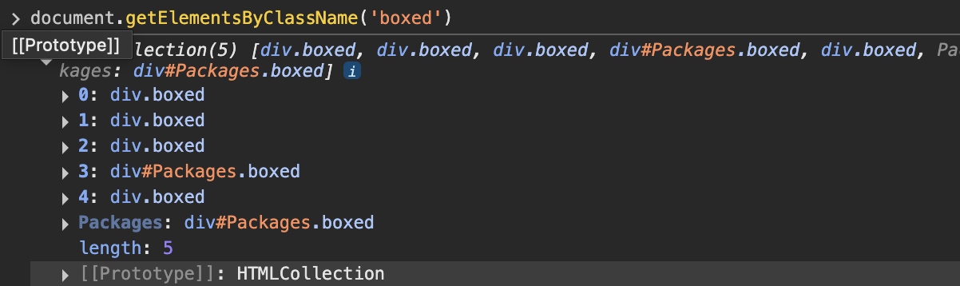

--------------

**querySelector() & querySelectorAll():** I have to separate these things because these are conbination improving from those 3 above that we have seen

* querySelector()
  + to select tag name, class name, id and css style
  + All-In-One Methods
  + This selection can select only one thing that first met
  + To select is like to select in CSS
    - Class = .class-name
      * Document.querySelector(.class)
    - ID = #ID-name
      * Document.querySelector(#id)
    - Tag = tag-name
      * Document.querySelector(tag-name)

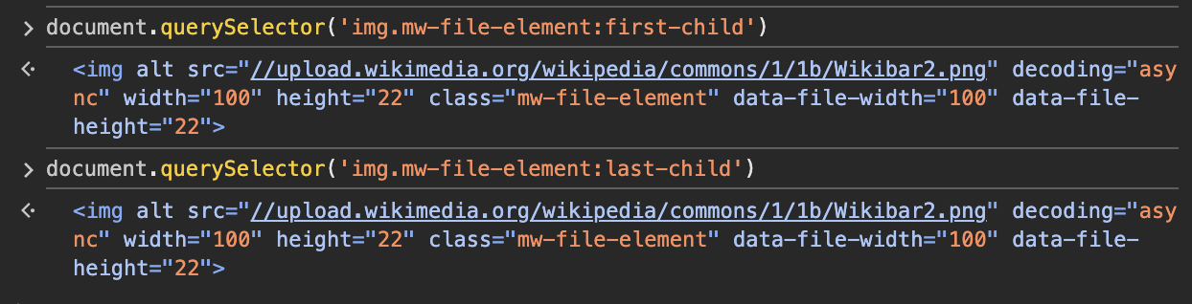

* + - From example, you can see we use querySelector to select specifies the img that we want though css command like first child, last child etc.
    - And like you see I’m selecting ‘tag.class-name:css-commend’ – like this to more specify
* querySelectorAll()
  + it works similar to *querySelector()* but not only one but get all element that exists from selection

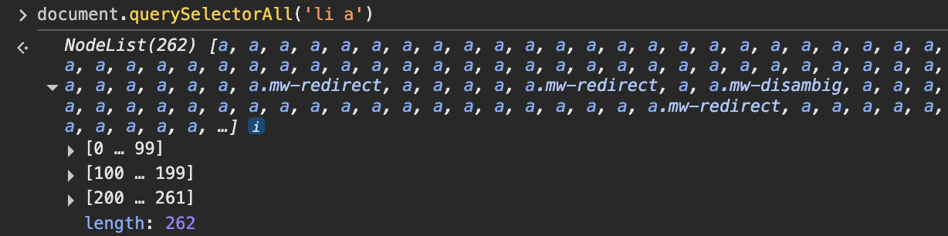

* + the type of this querySeelctorALl & querySelector are *‘NodeList’* it’s like *‘HTMLCollection’* that’s length and we can access by its index, but it’s not real array
  + We can access by its descentdant like this tag ‘*p li*’

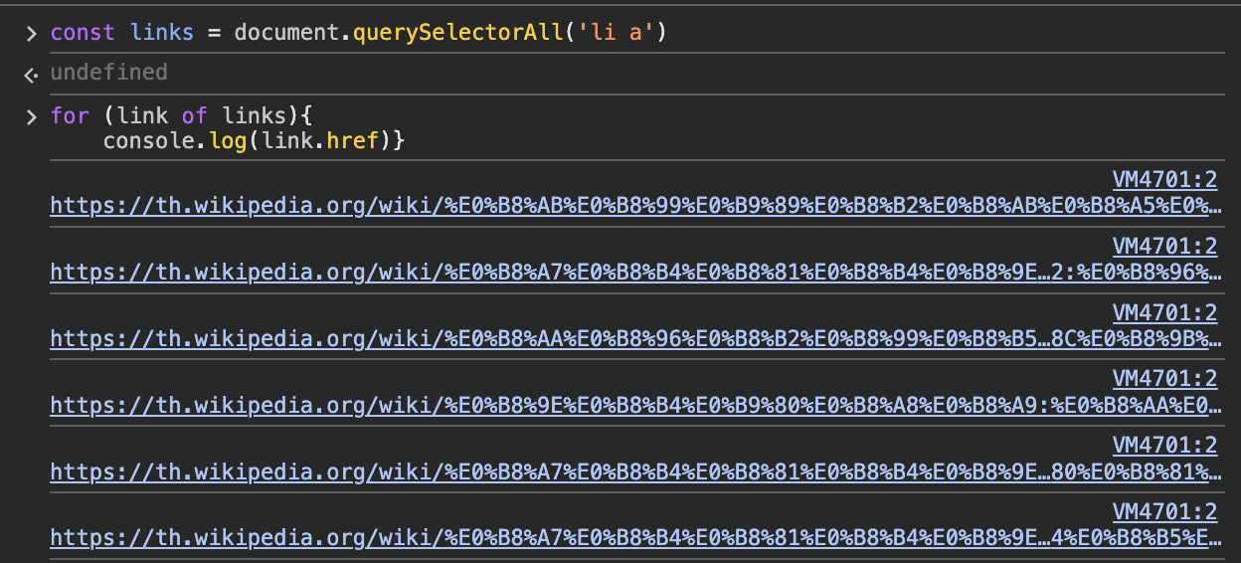

* + So, now I can fetch all link on anchor tag

DOM Manipulation

* innerText
  + the method that can retrive only text that has appered on display HTML, if it doesn’t, it won’t be seen
  + we can alter text through this method. See this



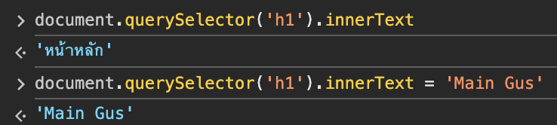



* + If I set display to ‘none’ the innerText will not see this text when we select



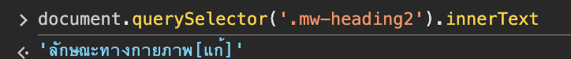

* + Then I change the span text to not display by using innerHTML



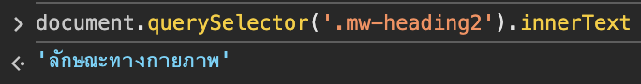

* + Now, we can’t see the text that we have hidden it
* textContent
  + This is similary to innerText but when we select, we can see all text inside although it hidden



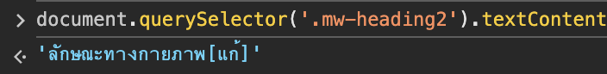

* innerHTML
  + we can change the element through this method
  + we can change by select that tag the using tag and text that we want to



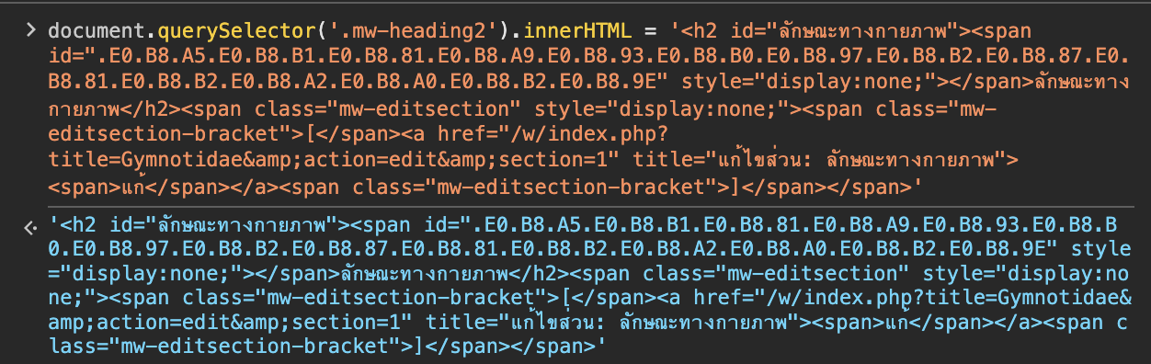



* + we can also concatenate text to element

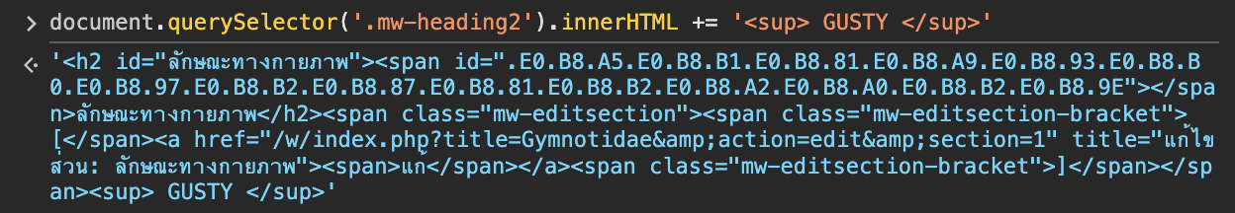 

Attributes

It’s HTML that’s stay in element like class, value, etc.

*<p align="center">This is paragraph.</p>*

From p tag we can separate to,

<p></p> = HTML tag

This is paragraph.= Element

align="center">= Attribute

* getAttribute

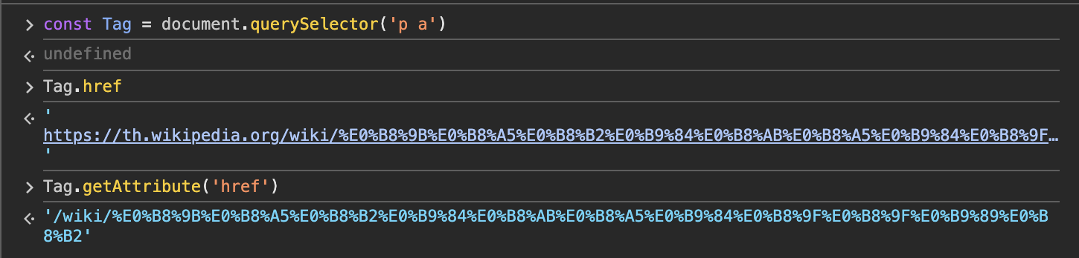

* + From above, tag.href = property
  + But Tag.getAttribute = Attribute
    - From we get from property, it gets through JS object
    - From Attribute, it gets from attribute that lay inside Tag does not get through JS

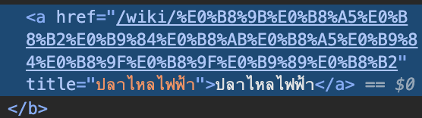

* + - But we don’t need to get serious on this we can use both for changing or something
* setAttribute



* + We can change attribute directly from this command

Style

* Select HTML tag.style = style to be changed



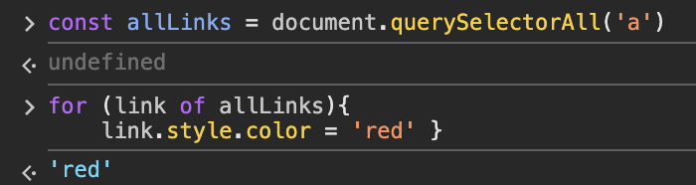

ClassList

This method is more effective for changing style more than stye.something to change it inline style, we can give new class name to HTML tag through JS then we can change it in file .css

* Dom select tag.classList.add(‘className’) <- to add
* Dom select tag.classList.remove(‘className’) <- to remove
* Dom select tag.classList.contains(‘className’) <- This is how to check that class active or not
  + It’ll give us True(contains) or False(No)
* Dom select tag.classList.toggle(‘className’) <- to toggle from true to false and from false to true

Traversing Parent/Child/Sibling

It’s about to accessing the elements

* Parent
  + You can see its *parent element* from the current element that you are qurrying

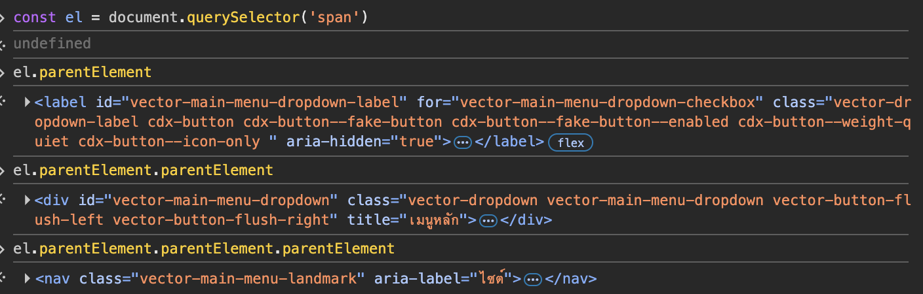

* + You can see its through command *parentElement*
  + you can repeat this command to see the top notch
* Child
  + It got three commands

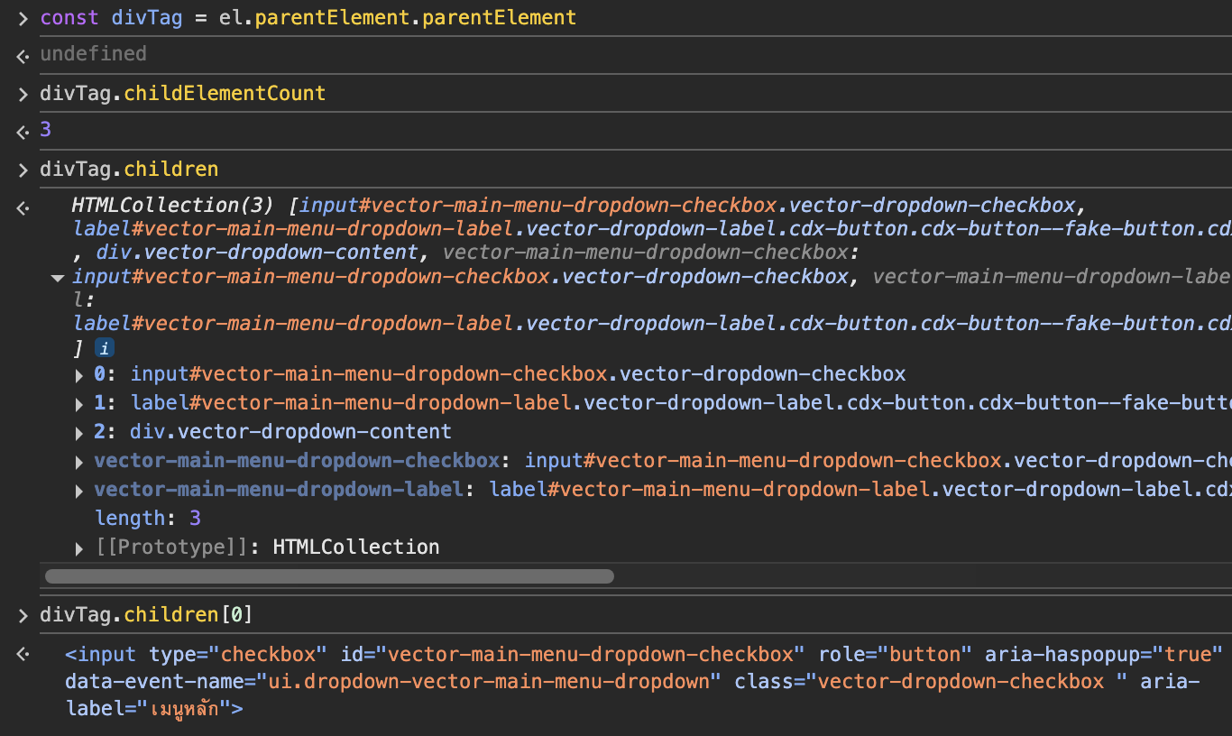

* + *childElementCount* <- to see the number of that element contains
  + *children* <- to get HTMLCollection(like array but it’s not) for iterate to get something or see it contains in detail
    - you can access its indice, but can not use array methods
* Sibling
  + nextElementSibling <- give next element that nearby, if it exists
  + nextSibling <- give us text node, that provide all kind of node like text node, comment node, element node
  + previousElementSibling <- give previous element that nearby, if it exists
  + previousSibling
* PS. Every element only has one parent, but they could have multiple grandparents or children

Append & AppendChild

It’s about to creating a new element and appending it to the page

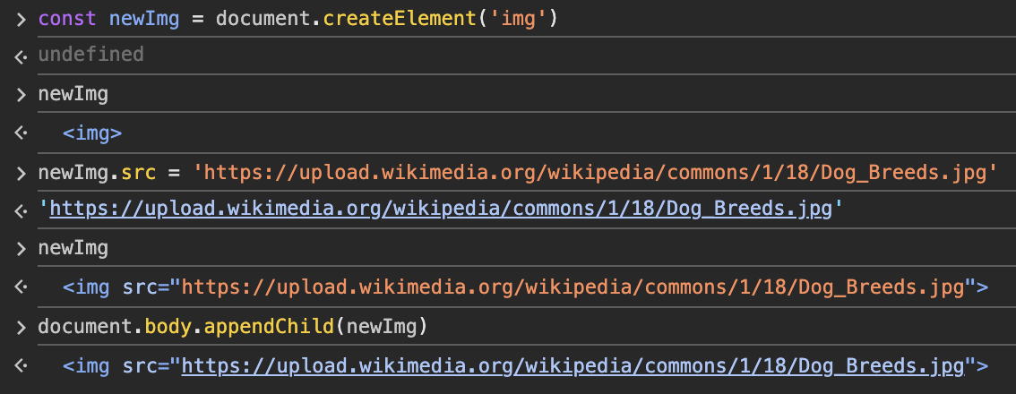

* From above we have add the dog’s img to Wikipedia page
* We use *createElement* then *appendChild*
  + document.createElement(‘desire element tag’) <- to create
  + then insert the value into that
  + document.address tag.appendChild(variable that kept value and element tag) <- append to web page
* append()
  + we can use this to append any thing directly that appendChild can not do this
  + document.body.append(‘I am new’) <- this appendChild can not do

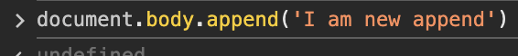

* prepend() <- to append previous that tag (from querySelector/All)

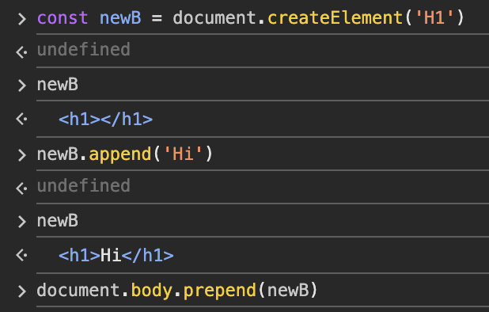



* *InsertAdjacentElement(poistion,element)* <- insert between tag that are adjacent, it’s not be child from both it will be another sibling to them
  + Position <- you can choose position of that main tag that you’ve mentioned to
    - *‘beforebegin’* <- before the targetElement itself
    - *‘afterbegin’* <- inside the targetElemnt, before its first child
    - *‘beforeend’* <- inside the targetElemnt, after its last child
    - *‘afterend’* <- after the targetElement itself

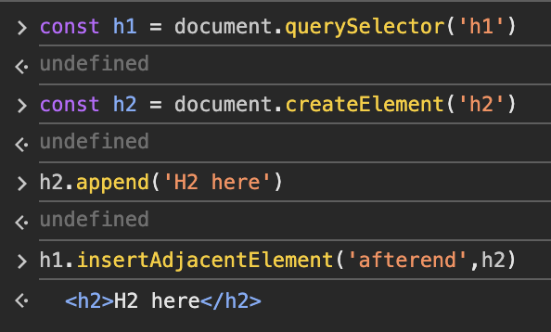



* *after()*/*before()* <- insert before or after that element target

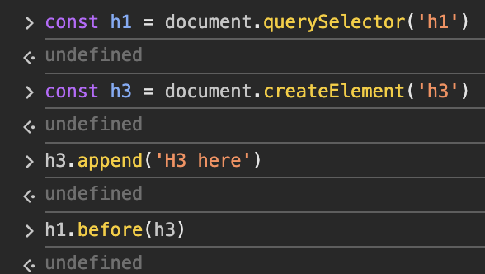

Remove & RemoveChild

* elementTag.parentElement.removeChild(‘elementTag) <- this kind a old method to remove element, if you wanted to remove that element you need to select its parent element first then you can remove
* elementTag.remove() <- you can remove it, it’s like ‘remove me’ don’t mind about its parent element or something (No arguement)

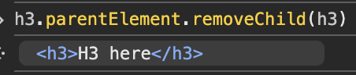

* above is removeChild()

 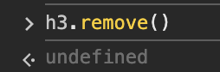

* above is remove()

**DOM Events**

**DOM Events:** it’s to response to user inputs and actions, do anything to response and make the web to be interactive

Inline Events



* This kind of junky, not efficientcy <- Colt does not recommend

Property

In DOM, the events are also on the property so we can access them by using em in format of property equal to function

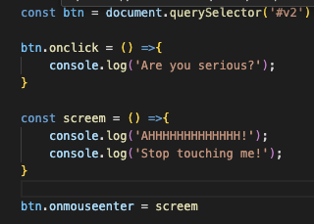

* Onclick <- user click then activate function
* Onmouseenter <- user hover the button, action active

addEventListener

* Element.addEventListener(‘action input’, callback function) <- Recommanded

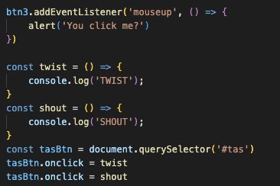 

* The reason why we prefer this more add the action to its method directly
* From tasBtn I’m add 2 onclick properties
* I cilcked it 4 times, and didn’t show me twist
* Because its property can have only one property

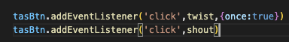 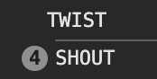

* addEventListener can do two of those
* and it contains about the option
  + once <- this will action one time
  + you can see other options in MDN

Events & The Keyword *This*

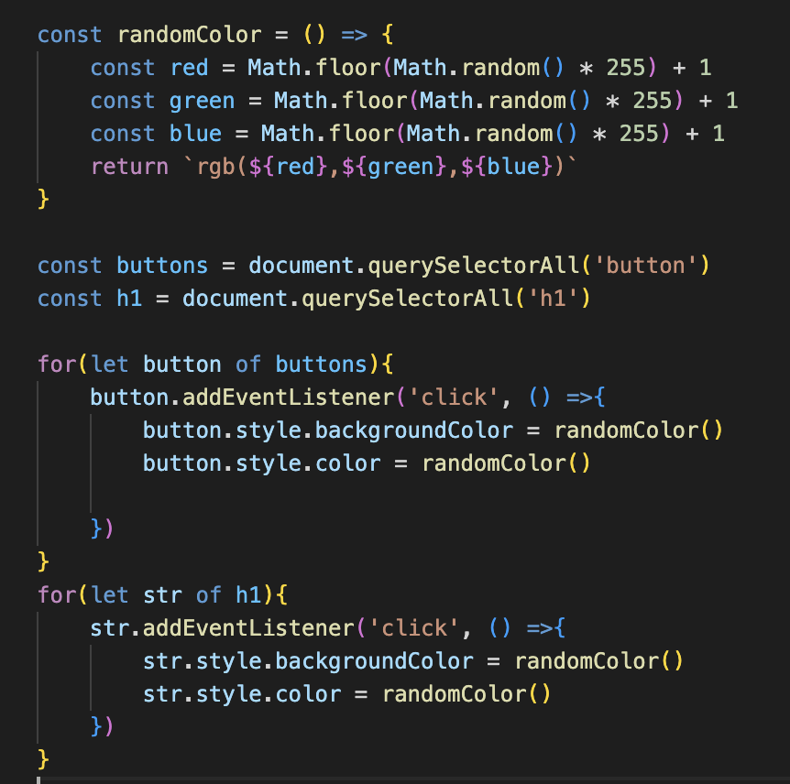

* this program is doing of randomly change color of their background and their color for button and H1 element, we have to to fourth times!

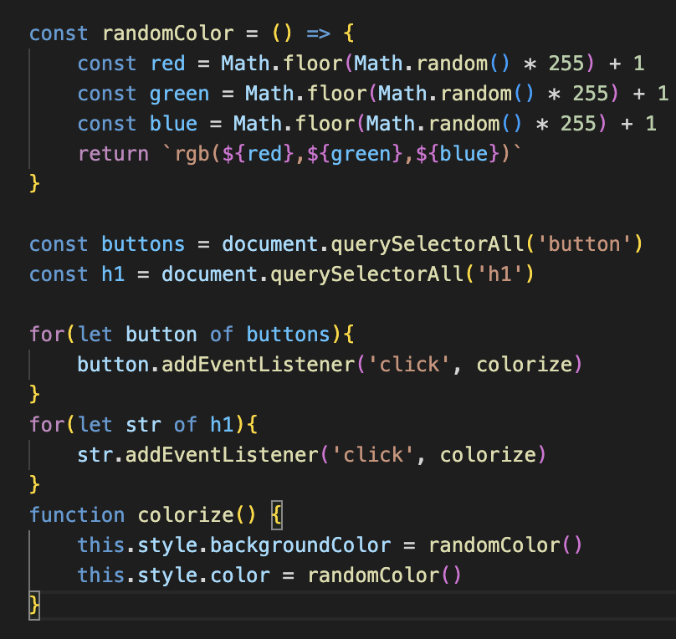

* we can use ‘this’ instead of do the hard coded, but you must beware of
  + we can’t use arrow function with ‘this’ method, because arrow function doesn’t have ‘this’

Keyboard Events & Event object

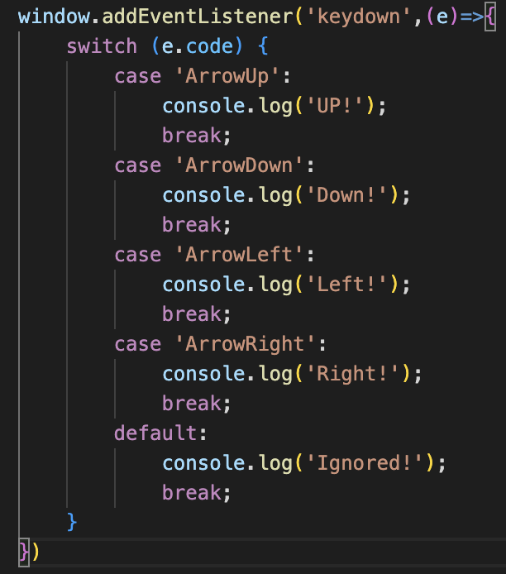

* we can capture input from keyboard for any purpose

Form Events & PreventDefault

* submit form by default and prevent that behavior

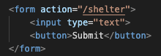 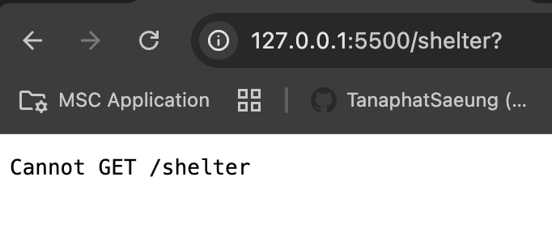

* it’s a route from HTML, it will change to other page when I clicked the submit button
* to prevent this default, I have to use
* event.preventDefault()

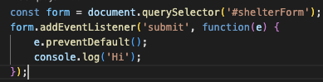

* So, it will not route to that you have put into action form

Input & Change Events

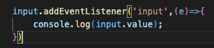

* Input
  + Fires every time the value of an input field changes
  + Happens immediately while typing or when pasting/deleting text.
  + Great for "live updates" (like showing character counts or real-time search results)

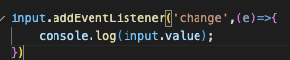

* change
  + Fires only when the input loses focus after its value was changed.
  + Doesn't fire for every keystroke - only after you finish typing and leave the field (or press Enter in some cases).
  + Useful for forms where you only care about the final value, not live updates.

Event Bubbling

* It’s about the hirarchy for me(bubbling)

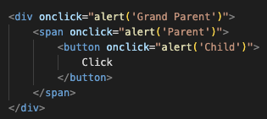

* I have created this that the button inside span and div
* When I clicked on this button, it shows me the triple message not just the alert on button <- This is ‘bubbling’ the hirarchy that from child(button) till its root(document) or top notch (from insider to outside)
* From this, it will trigger code from the button then span then div, step by step
* And we don’t need this, we want to run once event and we want only button event to be triggered, so we used
* Event.stopPropagation()
* From this it will only run this once and correctly trigger

Event Delegation

* It’s about the property ‘*target*’

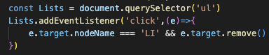

* If we want to use this property correctly, we have to think about its family
* From this I have to query its parent(ul) for li
* So, now I can access and delete it(if I wasn’t using this method, it will delete only its past not current ‘LI’)
* And the ‘target’ property is in the event (event’s property)

**Async Await**

Call Stack

* In computer science it’s like Last in First Out (LIFO), Think of the stack of the pancakes. The top of the stack pancakes is the last thing to be added to the stack and when we removed, we have to remove from the top not the buttom.

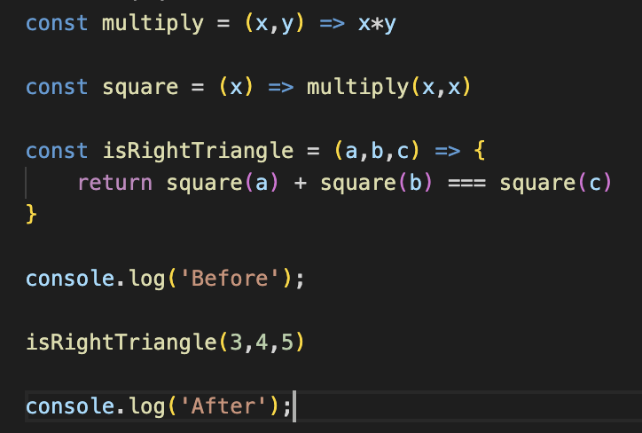

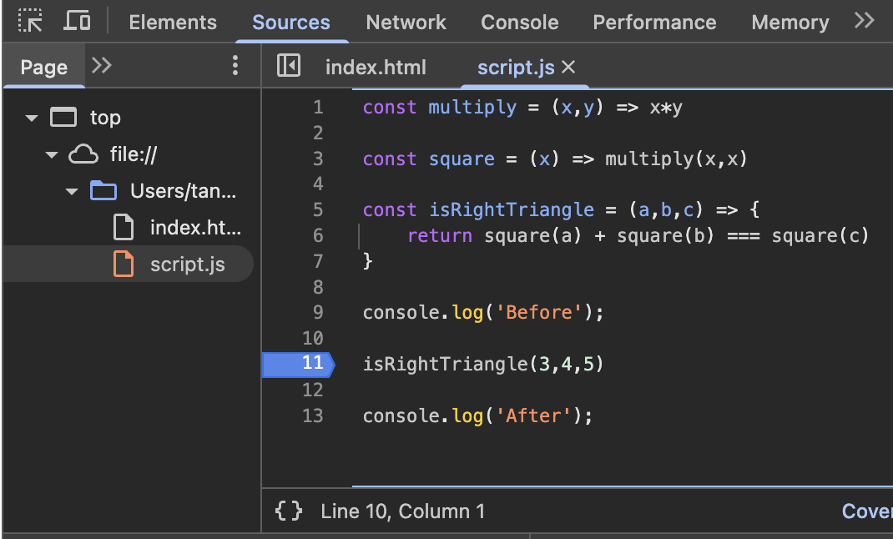

* From Code above, This is how to debuging on Chrome, I have added the breakpoint on the line 11 <- then you have to refresh once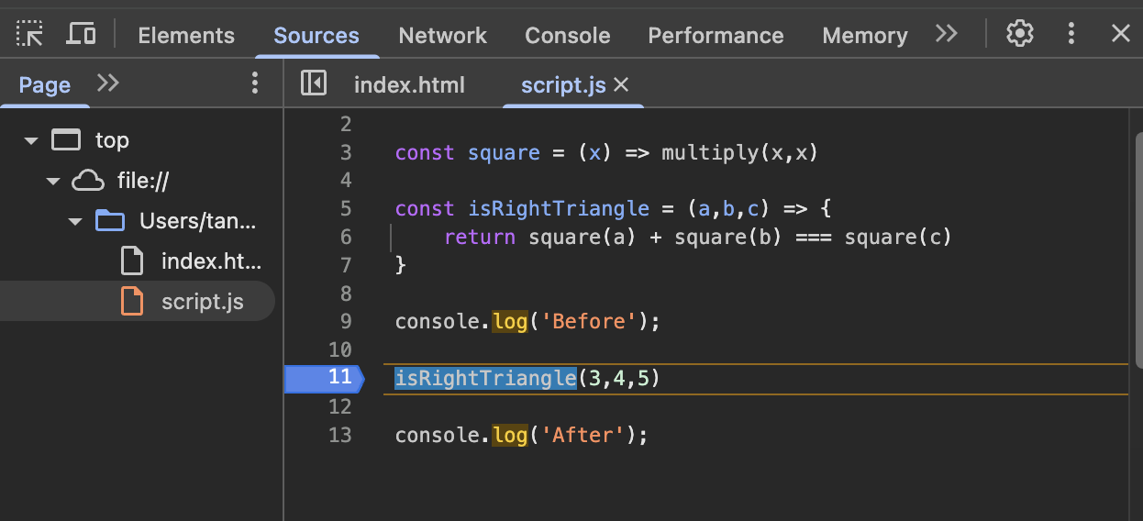

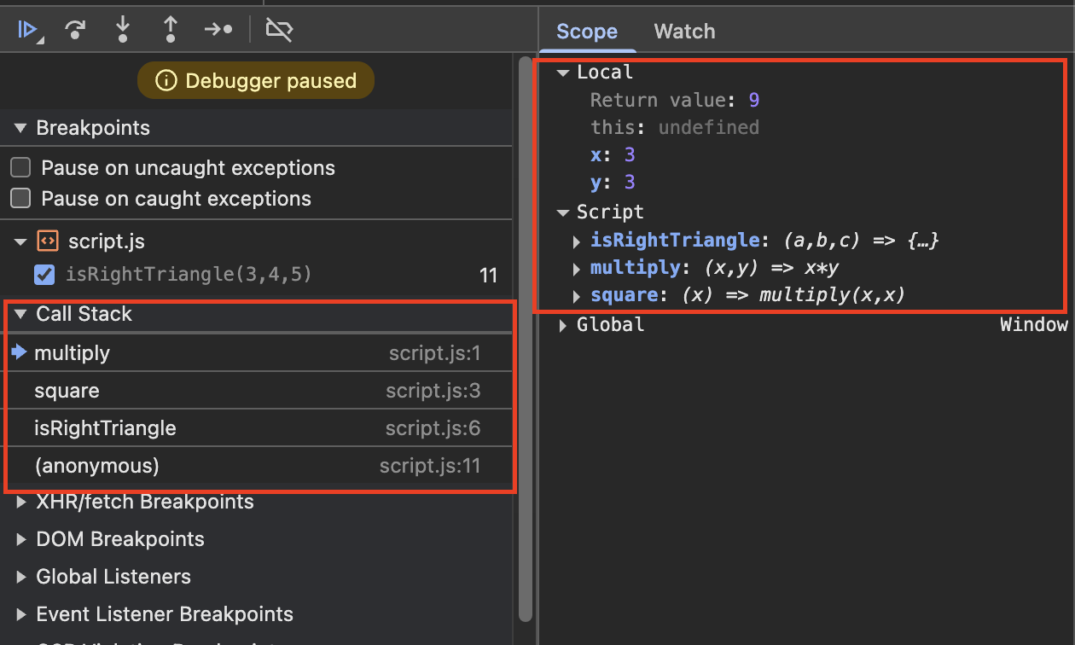

* From the debug, you can see the call stack of LIFO
* We have call ‘isRightTriangle’ this function doesn’t return anything to us, it has passed the input value to another function till the end of the function ‘multiply’, This function calculates till it ended then it returns till ‘isRightTriangl’ Function and return the value that we have sent. It doesn’t calculate from the begin but it passes and wait till those functions have finished then it returns
* It does step by step

Web API and Single Threaded

* JS is Single Thread <- This mean JS can work on 1 process in any given point, it can’t work multiple task it can do only 1 line at 1 time
* This section explains about how it works when it come to do the task that has to wait for the result like, when the user’re searching something and those input has to query by calling the API, API send the input to backend, backend send it back <- these take time, So for JS it will skip those task to next part , it doesn’t wait those tasks to finish but it will run next, and when those tasks finished it will appear later
  + So we need callback to handle this

Callback Hell

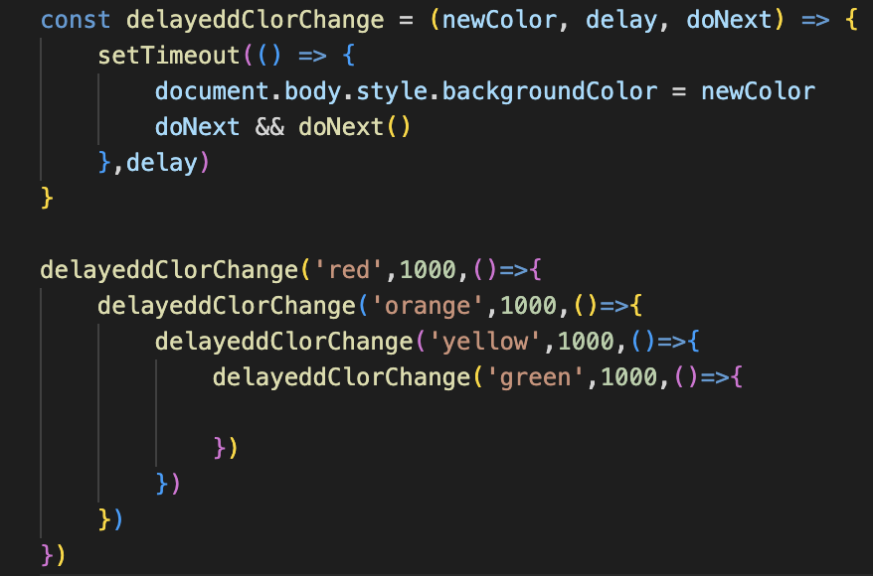

* This is callback hell: because this is nested and complex
* But next promise will help this out

Promise

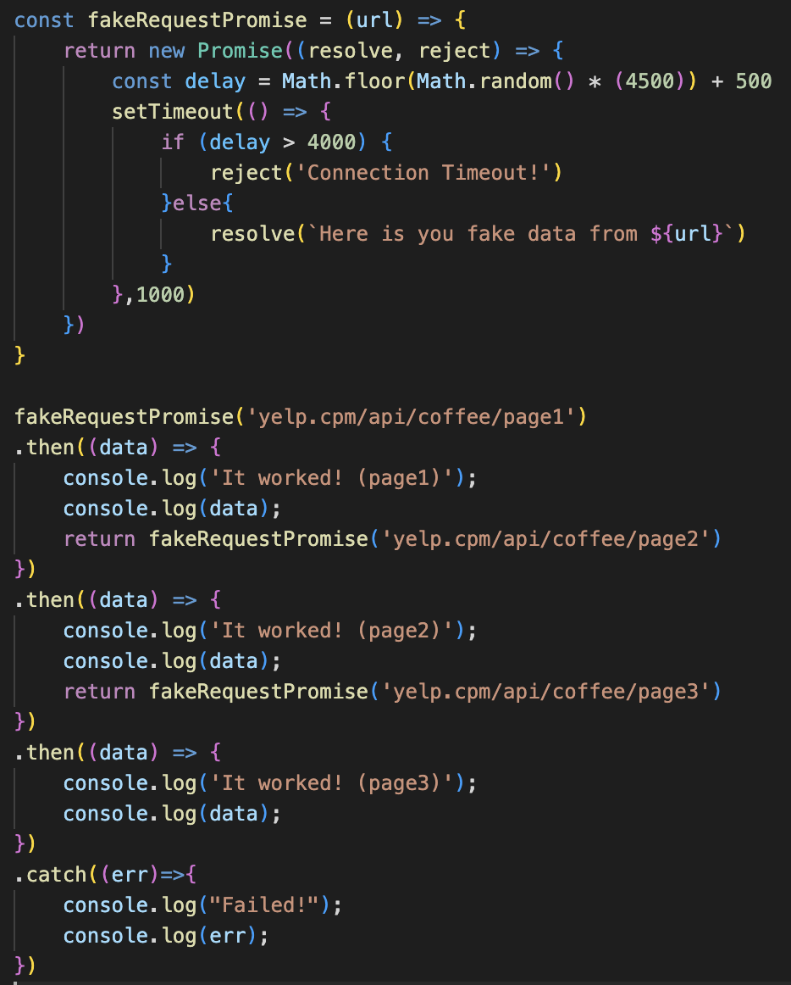

* From this you can see the promise has impoved the callback function for easier. It’s no more nested and complex but still has to chain together
* Promise still have ‘Promise’,’resolve’,’reject’,’then’,’catch’ <- These rules have to follow

Async

* It’s built on top of promise
* It makes the code a lot of cleaners
* We put async in front of the function and that function will automically return promise
* If the function return with value, that’s mean promise has sent resolve with that value
* To catch reject or resolve, we can use try{} catch{} to catch <- this is the best practise to do every time

Await

* Put await infront of function that lay inside async function, to wait this first before going to next line
* Async and Await can use then and catch for catch an error

**AJAX and API**

AJAX

* AJAX stands for Asynchronous Java script And XML
* This is the technique used in web development that *allows web pages to* *communicate* with a server in *the background, without reloading the entire page*.
* This makes web app faster, more dynamic and more interactive

APIs

* API stands for Application Programming Interface
* It’s like a bridge that lets two pieces of software talk to each other by following a set of definded rules
* It’s like a remote control lets you operate a TV without knowing its circuits inside work <- this is like API work, you don’t even care How the inside program work You just need to know, only how to ask for the data
* Requests and Responses: You send a request to the API, API sends back a response to you that you are asking for (you must following its rules for asking the data)

JSON

* JSON stands for Java Script Object Notation
* The format for requests and response for API
* There are 2 formats
  + Originally there is XML that are the old fashion
  + JSON, this is we are using nowadays
* We must use only double quotes, single quote is invalid for JSON
* JSON is a format for API, so we can use JSON format to get data or send via API by any languages not only for JS
* JS can turn JSON format to object by
  + JSON.parse(json data)
* JS can turn object to JSON before sending data to API
  + JSON.stringify(value)

HTTP

* HTTP Verbs
  + GET: only for get data, not passing any object to its body
  + POST: need body for to get of do something to server
* HTTP Status code
  + 200: OK
  + 300: Multiple choices
  + 400: Bad Request
  + 401: Unautorize
  + 404: Not found
  + 500: Server Error
* Query Strings
  + To working with differenet API and endpoints, each endpoint tends to mean something different
  + Query String: to get extra information to the server when making a request. It comes adter a ‘?’ using key-value and each key-value is seperated by &

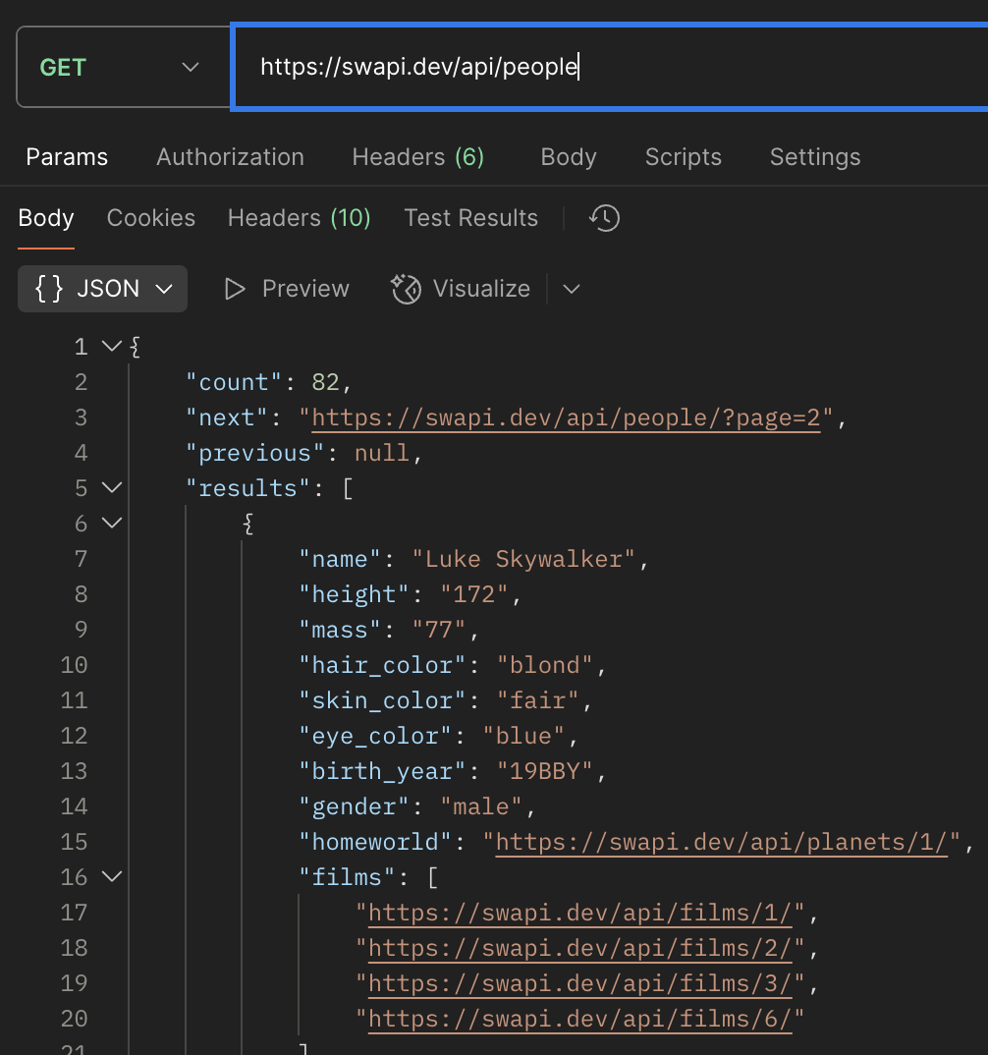

* + <https://swapi.dev/api/people> <- normal

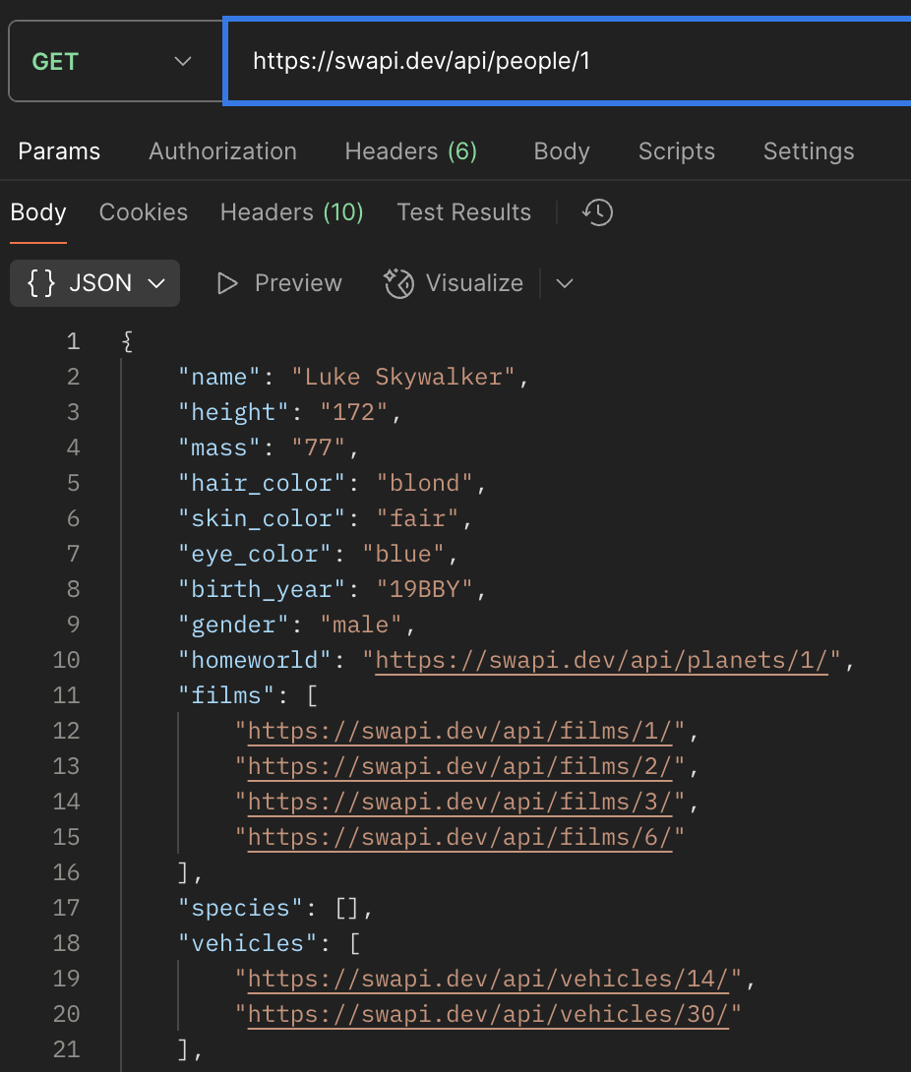

* + <https://swapi.dev/api/people/1> <- sepecify

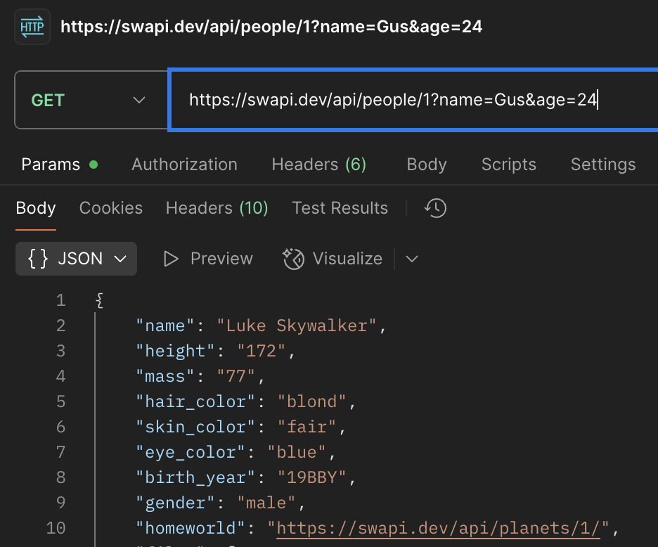

* + https://swapi.dev/api/people/1?name=Gus&age=24
  + You can append everything you want using a query string after the question mark’?’ and it will always be Ignored if those key-value are not match for extra information
  + From the example it doesn’t care the query string, it still responses the data

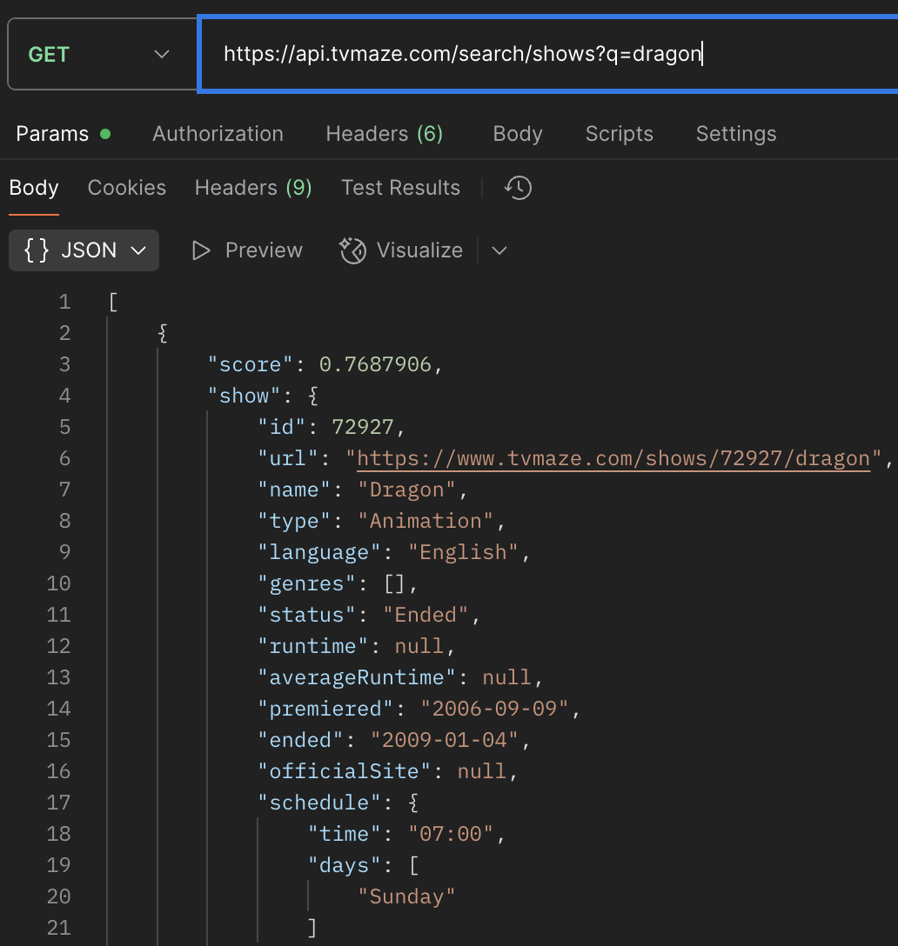

* + https://api.tvmaze.com/search/shows?q=dragon
  + And this example show if the key-value has matched to get the extra information
* HTTP Header
  + Herders are an additional way of passing information with a given request and also with a response
  + Like metadata(It means data about data[to descripe about other data]) that add on detail
  + Header descripe about the data From API (req,res)
  + Some APIs need to send header along with the body data to allow something like

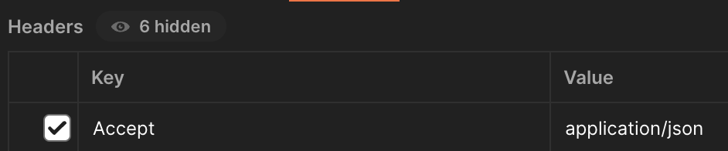

* + We send this along with the body data because the server is expecting the data has to be JSON format

XHRs (Not Important)

* To making request from JS with XHR <- no need to memorize these syntax

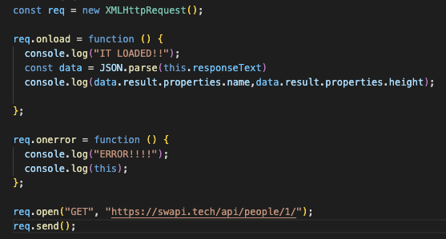

Fetch API

* New methods for making request

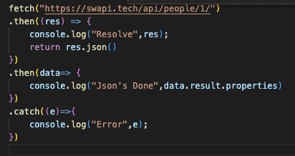

* With Call back

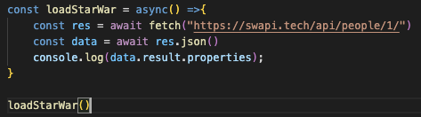

* With Async Await

Axios

* A library for making HTTP requests
* To use axios not the only way to npm install axios, there is other way to install by not using NodeJs

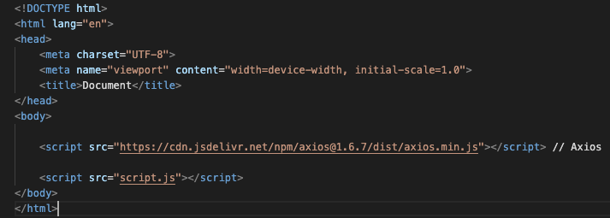



* + Add this line to html to using Axios

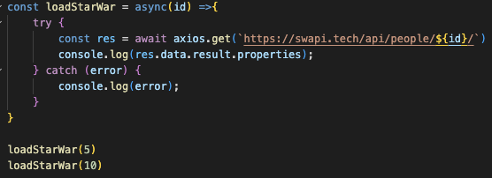

* Axios is no need to convert to json, axios will help us for that
* Axios with Header

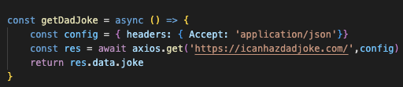

* + Set header to get content to JSON format

**Prototypes, Classes & OOP**

Prototype

* It’s a special Object on JS that other object can *inherit* properties and methods from
* __proto__ <- some call ‘Dunder’ <- this is inside everything or any object in the *browser*
* __proto__ is a special property that points to the prototype object that the current object inherits from
* In the array or any object that appear in, there is not reaaly inside it, it’s a special internal property of every object, used to connect it to its prototype
  + Like array, the __proto__ points to the array inherit methods like .push(), .map(), .filter() from *Array.prototype*

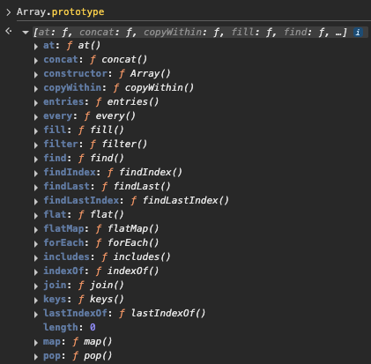

* You can create a new prototype via ‘object.prototype.new prototype name’

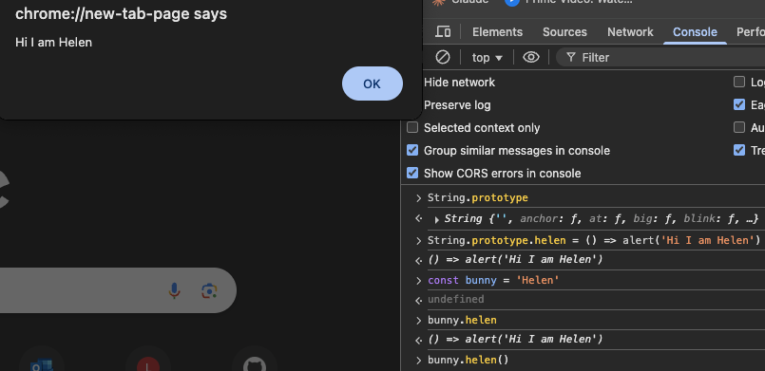

* + Like this I have added the new prototype to String’s prototype
  + You can replace the existing prototype too (you can do doesn’t mean you should)
* __proto__ vs prototype
  + Prototype = It’s the actual object that we add the new method to or the property
  + __proto__ = the reference to the objects prototypes

Object Oriented Programming

This the root of the next topic like Factory fucntion, Constructure function, JS classes, extends and super keywords <- These all begin from the same root, which is OOP.

* OOP is a style of programming where you organize your code around *objects* instead of just functions and logic
* OPP Principles
  + *Encapsulation*: bundle related data and methods together in an object.
  + *Abstraction*: hide complex detail, expose only what’s necessary
  + *Inheritance*: create new classes based on existing ones
* In short
  + OOP is a way to structure code with objects, classes, and inheritance, making it to be reusing code and to model real-world things

Factory Functions

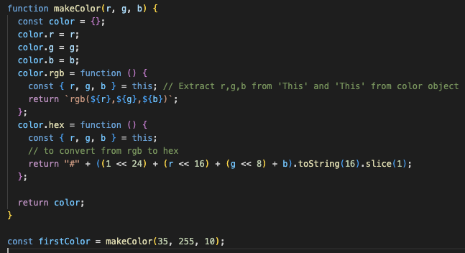

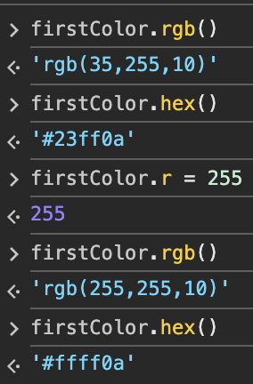

* Factory function: it’s a simply function that creates and returns objects. It’s called a ‘factory’ because it manufactures objects for you, instead of manually writing out each object or using class
* From the example I have create a function that contain 2 functions with using ‘this’ and extraction
* So, I can access those functions through those methods hex() and rgb()

Constructor Functions

* It is used to create objects, usually with the ‘new’ keyword
* It’s a normal function but by convention its name starts with a capital letter
* Call it with the ‘new’ keyword
* ‘new’ does 3 things
  + Crate a *new empty object* {}
  + Sets ‘this’ inside the function to refer to that new object
  + Returns the new object (unless we return something else manually)
* It shares properties and methods
* We can add methods via prototype by using ‘prototype’
  + If we add the function in constructor function, it’s a function that inside function it’s not prototype
  + 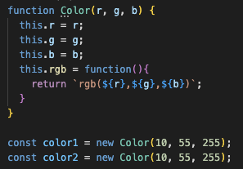
  + From this I have declared inside it
  + Every time I declare a new Color, JS creates a brand-new copy of the rgb function, and color1 and color 2 are different function objects in memory (not value)
  + Problem is, if I declared like thousands of colors, each one would store its own copy of the rgb function <- This waste a lot in memory

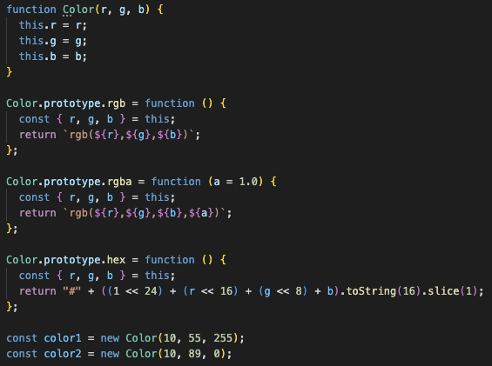

* We should declare like this via prototype
* This will share the same memory and every color will point to the same <- this’s better
* Constructure function is better than Factory function because of Memory efficientcy that are explained above <- contain prototype

JavaScript Classes

* This is like Contructure function but cleaner
* Declare begin with class and uppercase

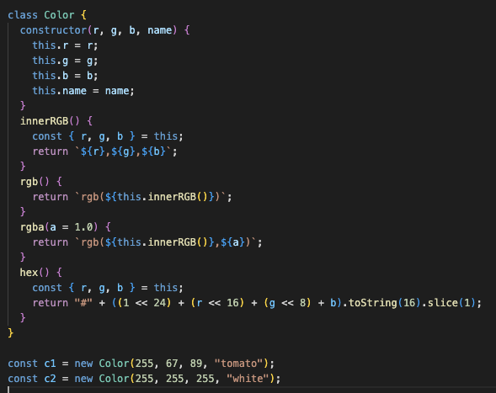

* From the example, you can see this like constructure but has class cover the entire function
* We can declare the prototype without typing prototype
* I have use ‘this’ keyword for more professional and cleaner
* We add r,g,b and name to construtor for first load if we call this class and this is where we set up instance-specific variables

Extends and Super Keywords

* Both have to do with sub-classing
* Extends
  + They are using for inherit from another class
  + The new class (child) gets all the properties and methods of the parent class
* Super
  + It’s used inside a child class
  + It lets you
    - Call the parent’s construture <- to initialze ‘this’
    - Call parent methods <- to reuse/extend behavior
  + If your child class has a construture, you must call super() before using ‘this’ because the parent’s setup has to run first

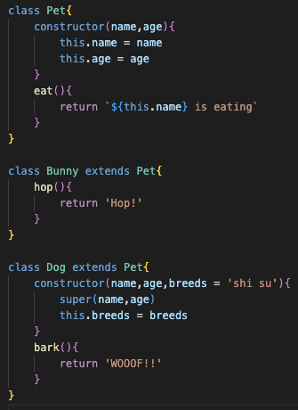

* From the example, I have created a parent class ‘Pet’ and it’s inherited to ‘Bunny’ and ‘Dog’ classes
* I use ‘super’ to Dog class inside constructure

**Terminal**

**Why should we use Terminal?**

* Speed
  + If we can remember all the commands and do it with the right syntax, we can do multiple things with just one line
* Access
  + We can modify permission, view hidden file that don’t show to Average user or UI
  + Create hidden files and modify them
* Tools
  + NodeJS, Express, DB that we can command these through command

Terminology: these all the same idea but not the same thing

* Terminal
  + Terminal used to be a physical object, but now it’s a software terminal
* Shell
  + Is the software that run on the terminal
* Bash
  + This is one of the most popular shells
  + This is the default on All Macs
* Z-Shell of ZSH
  + This the newest Shell, so newer than bash
  + Some command can run on zsh but not on bash
  + From bash is the standard for shell, now zsh is the default for MACs

Commands

Man

* To give information about other commands like ‘man ls ‘
* It’s like F1 in AS400

Touch

* To make a file not folder
* Touch index.html script.js style.css
* Create 3 files

Remove

* Rm = remove file
* Rmdir = remove dir
  + Rm -rf <- This can remove the folder with items in it